VIETNAM NATIONAL UNIVERSITY OF HOCHIMINH CITY
THE INTERNATIONAL UNIVERSITY
SCHOOL OF COMPUTER SCIENCE AND ENGINEERING

By
Dang Nguyen Truong Huy

Web Application for Optimizing International Freight Costs, Time, and Routes with Real-time Tracking and Disruption Handling

MSc. Nguyen Quang Phu

A thesis submitted to the School of Computer Science and Engineering
In partial fulfillment of the requirements for the degree of
Bachelor of Information Technology

Ho Chi Minh City, Vietnam
Year 2026

APPROVED BY: ________________________________ ,

________________________________

________________________________

________________________________

________________________________

THESIS COMMITTEE

ACKNOWLEDGMENTS

I extend my deepest gratitude to my supervisor, Nguyen Quang Phu, for his invaluable guidance, insightful feedback, and unwavering support throughout this project. His expertise and encouragement were instrumental in shaping the direction and quality of this thesis.
I am particularly grateful to VN Express International Delivery Company Limited (VNEXID) for their generous cooperation. The company kindly provided access to real operational data and granted approval for its use in this study under strict anonymization protocols. Their cooperation to share practical insights and operational context greatly improved the system design, implementation, and evaluation presented in this thesis.

Table of Contents
ACKNOWLEDGMENTS 3
ABSTRACT 9
CHAPTER 1 11
INTRODUCTION 11
1.1. Background 11
1.2. Problem Statement 12
1.3. Scope and Objectives 13
1.3.1. Scope 13
1.3.2. Objectives 13
1.4 Assumption and Solution 13
1.4.1. Assumption 13
1.4.2. Solution 13
1.5. Structure of thesis 14
CHAPTER 2 15
LITERATURE REVIEW 15
2.1. Overview of International Logistics and Air Freight Challenges 15
2.2. Related Work 15
2.2.1. ups.com: A delivery tracking, real-time, and price support 15
2.3. Literature Review 16
2.3.1. Freight Route Optimization Algorithms 16
2.3.2. Weighted 16
2.4. Real-time Shipment Tracking and API Integrations 16
2.5. Impact of Geopolitical Disruptions on Air Freight Routes 17
2.6. Digitalization of Logistics for SMEs in Emerging Markets 17
2.6 Research Gaps and Contribution of This Study 17
CHAPTER 3 18
METHODOLOGY 18
3.1. Overview 18
3.2. Thesis Procedure 18
3.3. User requirement analysis 18
3.3.1. Purpose: 18
3.3.2. Functional Requirement 19
3.3.3. Non-Functional Requirement 19
3.3.4. Use case diagram 21
3.4. Sequence Diagram 23
3.5. System Design 25
3.5.1. System Architecture 25
3.5.2. Design Pattern 27
3.5.3. Development Environment and Technology Stack 27
3.5.4. Database design 29
3.5.5. User Interface (UI) design 32
3.5.6. Algorithm design 32
CHAPTER 4 34
IMPLEMENTATION AND RESULTS 34
4.1. Implementation 34
4.1.1. Overview 34
4.1.2. Code Implementation 34
4.2. Results 38
4.2.1. Home Page / Landing Page 38
4.2.3. Data Synchronization and Fresh Tracking Context 40
4.2.4. Route Visualization and Disruption-Aware Rerouting (Core Application) 42
4.2.5. Security Measures in Operational Use 44
4.2.6. Consolidated Results and Achievement of Thesis Objectives 45
4.3.2. Algorithm Efficiency 46
4.3.3. Operational & Economic Value 47
4.3.4.1 Comparative Analysis 48
4.3.4.2. Cost Impact 48
4.3.5. Reliability and Security 52
4.3.5.1. Reliability 52
4.3.5.2. Security 53
CHAPTER 5 56
DISCUSSION AND EVALUATION 56
5.1. Discussion 56
5.2. Evaluation 57
5.2.1 Baselines 57
5.2.2. Experimental Protocol 57
5.2.3. Threats to Validity 57
5.2.4. Quantitative Results and Analysis 58
5.3. Limitations and Challenges 58
CHAPTER 6 59
CONCLUSION AND FUTURE WORK 59
6.1. Conclusion 59
6.2. Future work 59
REFERENCES 61

Table of figures
Figure 1: Landing Page of UPS 15
Figure 2: Use case diagram of LogiShop 21
Figure 3: LogiShop Sequence Diagram 24
Figure 4: Monolith Architecture 26
Figure 5: ERD of LogiShop 31
Figure 6: Home Page 38
Figure 7: Create Account Form 39
Figure 8: Create Order Form 40
Figure 9: Detailed tracking panel with timeline of staff/admin 41
Figure 10: Package information from the customer view 42
Figure 11: TransportationMap Main Interface 43
Figure 12: Disruption Zone and Rerouted Path Visualization 44
Figure 13: Rate limit test result HTTP 429 45
Figure 14: Dijkstra 30 runs 46
Figure 15: UPS Freight data of 1ZB8678F6735719517 50
Figure 16: Tracking API of 1ZB8678F6735719517 51
Figure 17: Scenario S1 51
Figure 18: UPS Warehouse storage additional charge from 2025 to 2026 52
Figure 19: Geocoding Accuracy Test Results 53
Figure 20: 10 requests in 60 seconds 54

Table of tables

Table 1: Technology Stack Used in LogiShop 29
Table 2: Main Database Tables 31
Table 3: findReroute() Psuedo code 37
Table 4: edgeWeight (conceptual pseudo-code) 37
Table 5: dijkstra (conceptual pseudo-code) 38
Table 6: Consolidated Results and Achievement 46
Table 7: Dijkstra 500 runs 47
Table 8: Fragment workflow 48
Table 9: LogiShop workflow 48
Table 10: Workflow comparison 48
Table 11: Package 1ZB8678F6735719517 49
Table 12: UPS Freight cost of 1ZB8678F6735719517 50
Table 13: Test comparison price 52
Table 14: Rate Limit – DDoS 54

ABSTRACT

LogiShop is an online system that was created for international delivery purposes and for efficient shipping management. There is an increased need for international deliveries, but there are also difficulties for smaller and medium-sized businesses when it comes to their logistics. The fragmentation of tracking details and higher costs are among these difficulties.
The system LogiShop has been developed as a full-stack web app that employs a modular architecture and divides functionality between front-end, back-end processes, and data management. It facilitates key operations, from account-based access through the creation of orders, recording shipments, and tracking of their completion throughout predefined status stages. In addition to shipment tracking, LogiShop aims to facilitate logistics decision-making by arranging shipment data to allow monitoring of performance, identification of patterns, and avoidance of unnecessary overhead. Shipment visibility in terms of timeliness is provided to help customers respond promptly to any delays and set expectations about the delivery of goods in international settings. Regarding project implementation, consistency of data flows and stability of core logistics operations are prioritized by LogiShop. API communication has been chosen to link user operations to execute requests via back-end services; moreover, validation and standardization of request and response formats will ensure their correctness. Finally, the practical issues associated with the development of LogiShop have involved provisions for the future extension of the functionality to support, for example, the analysis of shipping charges, regional carriers, currency exchange, and international shipping alerts. This was done through functional testing and scenario testing of the core workflows in the system, including user registration, user login, order placement, shipment alerts, and track and trace acquisition. This result shows that the system satisfies all the important objectives, which involve delivering accurate orders and tracking processing, improving shipment information visibility, and creating a strong foundation for future international logistics management at reduced costs.
In conclusion, LogiShop demonstrates that a focused web platform can address both visibility and cost-efficiency challenges in international shipping workflows. The project contributes a feasible and extensible digital solution for economically informed logistics operations, and it offers a reproducible engineering framework for future work in the global e-commerce delivery system.

CHAPTER 1

INTRODUCTION

Background
The rapid expansion of global e-commerce has changed how goods are brought, sold, and delivered throughout countries. Consumers expect their goods to be available quickly at a reasonable price, with real-time shipment tracking if possible. At the same time, businesses all around the world begin to enter the competition through digital channels, creating a diverse logistics environment World Bank [1].
Despite the growth, logistics workflows in developing and transition economies still heavily rely on fragmented information systems. Shipment data and work are still managed mostly in spreadsheets, Google Docs, and Excel. Operations staff still manually handle their work by copying, checking, and processing order information. Customer support queries tracking numbers from carrier portals and websites. This results in a disconnect between providers and customers, leading to delays, inconsistency, and unavoidable extra fees.
Another major challenge is route-related visibility. In the most popular tracking systems worldwide, users can only view tracking events such as event logs (e.g., transit, arrived, etc.), but not geographically related events. Without a visible route visualization, operations staff have difficulty managing and detecting bottlenecks, leading to delays across the whole system. A system that can visualize transportation routes and order workflows can be a solution for the economic system.
International shipping can be significantly affected by disruptions. Geopolitical conflicts, war, port congestion, natural disasters, and more. Traditional planning does not perform well under such circumstances. So the modern logistics environment needs to be adaptive to change to provide effective solutions under constraints. Full optimization is unachievable, but with the introduction of disruption awareness, routing logic can be significantly improved, helping to reduce time, cost, and distance traveled.
Additionally, customer expectations are gradually increasing each year. They no longer accept delays or suspicious tracking data, especially for cross-border transactions with fluctuating values. They demand real-time updates and more precise estimates. From a business perspective, this means the logistics platform should serve as a bridge connecting carrier systems and end users, with continuous synchronization. Failure in this area can lead to customer dissatisfaction and directly affect the economy.
From a systems perspective, industrial transportation creates a clear need for a digital software platform that can combine multiple functions, including order management, tracking, route visualization, and analytics. The value of this platform is essential not only for technological convenience but also for operational economics.
LogiShop is positioned as a practical, implementation-oriented system rather than a theoretical framework. Its purpose is to support realistic workflows for small and medium-sized logistics operations. It focuses on centralized order data, route map visualization, and API-based tracking. The system emphasizes feasibility, maintainability, and scalability, making it easy to scale without requiring a full redesign.
In summary, the thesis's background focuses on three main trends: increasing cross-border shipping demand, consistent workflows in practical logistics operations, and handling international disruptions for delivery management.

Problem Statement
Despite international logistics being a significant component of e-commerce, most shipping activities are faced with inefficiencies, which limit the level of service delivery and add costs. The primary challenge that forms the basis of the thesis is the absence of a unified, economic platform that integrates order management, routing, and tracking coordination.
First, most enterprises have problems with data integration regarding order history, shipment updates, and route context. It requires employees to look up the relevant information manually to solve routine challenges, including questions like "Where is the current location of the shipment?" "Which corridor is overloaded?" and "What routes are currently at risk?" Such practices not only consume time but also contribute to the inconsistencies between the provided customer services and customers.
Second, there is no adequate geographical information. In today’s world, most tracking systems provide tracking statuses in a text format without any visualization. Although text-based tracking can be beneficial, it cannot meet the demand when it comes to tracking numerous shipments. Without route visualization, route management becomes difficult.
Another problem is that update processes in non-integrated systems might be manual and quite time-consuming. For instance, clients would need to refresh the information many times to get carrier information in order to make sure that the package is on its way. In case of delayed updates, decision-making could prove to be inefficient, leading to a failure in notification or contacting the customers on time. Moreover, for cross-border delivery, there could be several time zones involved, which makes things more complicated.
The next issue is related to disruption management as well. International shipping could be subjected to conflicts, natural disasters, political events, and other types of disruptions. Despite the prevalence of practical systems, the functionality that enables automatic evaluation of an alternative delivery route does not always exist. Therefore, a rerouting service that estimates and detects disruption would be an important tool to implement in the process.
Finally, it should be noted that economic issues could arise when implementing practical solutions to improve the situation. Typically, existing systems prioritize visibility without taking costs into account when making decisions about the delivery route. In international shipping, long-distance means higher prices and greater expenses, which become especially relevant from an economic standpoint for
To address this problem, the thesis develops a Web Application – LogiShop as a system that focuses on logistics workflows and introduces a disruption handling and reroute system. The work is intended to connect a basic tracking system and optimized logistics platforms suitable for a practical environment.

Scope and Objectives

Scope

This thesis focuses on designing LogiShop as a web application for international delivery. The scope includes order and tracking management, route visualization on a transportation map, with API update to help synchronize with carriers. Additionally, the work includes a disruption handling system to analyze and reroute to support decision-making under certain circumstances.
From a research perspective, the thesis evaluates the LogiShop system and the available dataset. It does not hold a claim to solve all logistic optimization problems on a large scale. But it delivers a practical system that addresses common workflow issues that appear in international shipping operations.

1.3.2. Objectives
1. To develop a logistics platform for managing international orders and shipment tracking in a single workflow.
2. To implement map-based route visualization with status for better operational.
3. To build an automated tracking refresh flow that synchronizes internal records and carrier updates with low manual effort.
4. To apply disruption handling routing logic for evaluating route feasibility and potential cost impact under disruption scenarios.
5. To assess functional and practical usefulness through implementation testing and scenario-based Solution.

1.4 Assumption and Solution

1.4.1. Assumption
For the website to work smoothly, some assumptions need to be made in order for the project to proceed.
The first assumption was about the interaction between users and the website. They were assumed to fill in all required field and accurate as possible to give a result. Information filled is also assumed not to change between fillings for the website.
The second assumption was about the preferences and priorities that affect how routes are calculated with constraints with fixed duration.
Thirdly and finally, assumed that with frameworks and functions, web applications can handle and process data given by both customers and operators effectively to provide results without errors.

1.4.2. Solution
The thesis proposes the LogiShop web application to be developed and provide an optimized system for user to choose their delivery and keep track of them. In this system, user fill out their package information in order for staff to handle them. As for the system, it will report to the user their delivery status, outline them on the mapping system with a detailed view. When a disruption occurs, operators can demonstrate it on the global mapping for users to interact and inform them if their package interferes with the affected zones. The result will give them the most optimized path for the delivery after calculating with the system, it will show them the cost and time they can save, and the distance between optimized paths.

Structure of thesis
This thesis is organized into six chapters, each hold a specific role in presenting the research motivation, technical, and evaluation:
Chapter 1 - Introduction
This chapter presents the background of the international logistics environment, identifies core practical issues, defines research scope and objectives, states assumptions, and points out the proposed LogiShop solution.
Chapter 2 - Literature Review
This chapter reviews studies and systems architecture related to logistic platforms, transportation, and disruption handling.
Chapter 3 – Methodology
This chapter details the technical tools that are used to implement the LogiShop Web Application, including architecture, modules, API, database, route visualization mechanism, and disruption handling framework.
Chapter 4 - Implementations and Results
This chapter describes implementations, results, and observations of the functional system. It presents how the system works across the web application.
Chapter 5 - Discussion and Evaluation
This chapter interprets the implementation outcomes, including baseline comparison, evaluation protocol, threats to validity, discussion of limitations/challenges, and comparative analysis.
Chapter 6 - Conclusion and Future Work
This chapter concludes the main findings and contributions of the thesis, with a focus on practical relevance. Also propose future enhancements.

CHAPTER 2

LITERATURE REVIEW

Overview of International Logistics and Air Freight Challenges

The international logistics field, especially air freight, is one of the most significant growth areas, boosted by the rise of global e-commerce and supply chains. Vietnam has also become a more export-oriented country over the past few years. Small and medium-sized enterprises (SMEs), which make up most of the business-related fluctuating freight rates, have limited capacity and manual processes. According to the World Bank [1], Vietnam’s LPI score of 3.3 reflects consistent but mid-level performance. These result in inefficient operation of logistics [2].
As global supply chains grow more complex, the need for digital tools to improve decision-making and resource allocation in freight transport becomes highly needed.

Related Work

ups.com: A delivery tracking, real-time, and price support
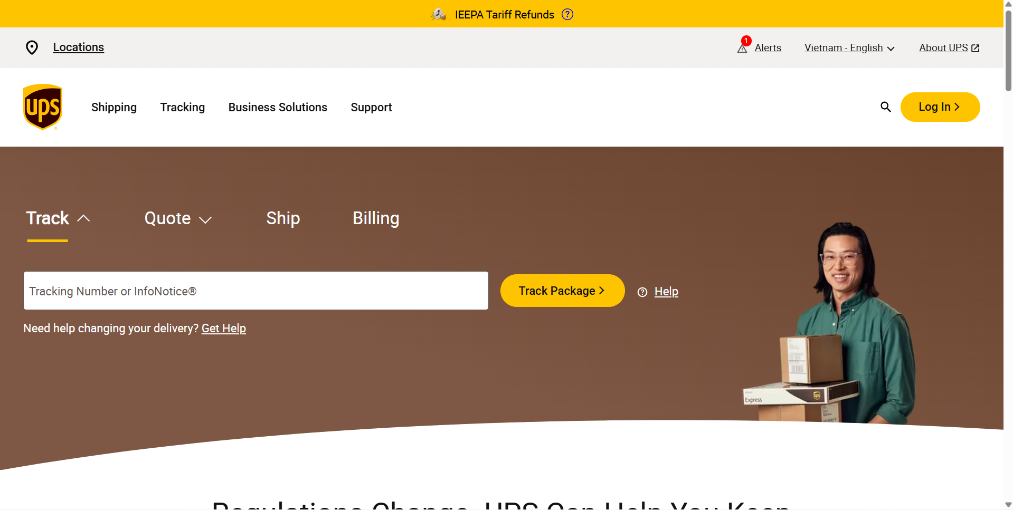
Figure 1: Landing Page of UPS
UPS is treated as an industry-standard visibility and pricing back end: the site submits identifiers and shipment parameters that UPS accepts, receives normalized responses, and maps them onto order records, status fields, and optional map visualizations built from scan locations.
When a user or staff member tracks a consignment, the application can resolve either an internal order identifier or a carrier tracking number (for example a UPS 1Z… style number), then call UPS’s track details endpoint so the platform obtains a current status, service description, package metadata where available, and a chronological activity list (timestamp, scan location, status code and description). The prototype’s service layer sorts and normalizes those activities into a single timeline and derives human-readable origin, destination, and “latest.”
On the pricing and rating site, UPS exposes self-service shipping calculators and quote experiences commonly structured as forms where the user specifies origin, destination, weight, dimensions, and sometimes speed or product, and the site returns published rate outcomes across eligible services, sometimes with add-on options (declared value, additional handling, etc.) that change the total.
For the advantages, UPS is a dedicated provider and recommends users worldwide to track their delivery alongside their rating system. Also include a FAQ section for answering or helping users with the most frequently asked questions.

Literature Review

Freight Route Optimization Algorithms
Route optimizations present a vital element in achieving efficiency of logistic systems. The traditional way relies on classic algorithms such as Dijkstra’s shortest path algorithm, which is still effective to this day. The algorithm serves as a core method for identifying optimal paths in graph networks [3].
The developments support the adaptation of optimization models to air freight, including cost, time, distance, carrier availability, and disruption, as related through optimization frameworks for cargo assignment and network planning

Weighted
Freight and intermodal corridors are often represented as a directed or undirected graph G=(V, E)G=(V, E), where nodes correspond to ports, hubs, or terminals and edges correspond to feasible movements with nonnegative arc costs (distance, time, or a unified monetary equivalent). The shortest-path problem seeks a route P between a source ss and a sink t that minimises total cost along the sequence of arcs.
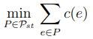
where P_{st} is the set of all elementary (s, t)-paths defined as sequences P =
(s = i₀, e₁, i₁, . . . , i_{l(P)−1}, e_{l(P)}, i_{l}(P) = t) of nodes ik ∈ V
edges e_{k} = (i_{k−1}, i_{k}) ∈ E with the property that no nodes (and thus no edges) are repeated
When all arc costs are nonnegative, Dijkstra’s algorithm is a standard label-setting procedure: it maintains tentative distances from ss, repeatedly selects the unsettled node with minimum distance, and relaxes incident edges to tighten bounds until t is settled (or the entire reachable component is processed). The relaxation step is the algorithmic core: if passing through node u offers a cheaper way to reach neighbour v, the estimate for v is updated.
d[v]←min(d[v],d[u]+c_{uv}​)
d[v]: The current shortest known distance to reach the node from the starting node
d[u]: The shortest known distance to reach node from the starting node.
c_{uv}: The weight (cost or distance) of the edge that connects node u directly to node v
d[u]+c_{uv}: The total distance of a newly discovered path to v, which travels through first and then takes the edge to v.

Real-time Shipment Tracking and API Integrations
Real-time update and tracking of shipment status is crucial for risk management and operational efficiency in international logistics. Most of the carriers provide their own application programming interfaces (APIs) to help. For example, UPS APIs enable real-time shipment tracking across various services (Freight, Express, Ground), delivering detailed status updates, location information, scans, estimate delivery date and time through RESTful endpoints with OAuth authentication.
To address the complexity of interfacing with a large number of carriers, third-party services begin to adopt the situation. Platforms such as Ship24 and TrackingMore provide global tracking with over 1500 couriers, including enterprise companies like DHL, FedEx, UPS, and e-commerce platforms such as Shopee. Those supports via webhooks (notification on status changes) [4], [5].
These aggregation approaches greatly reduce integration overhead, enabling seamless real-time tracking for modern web applications with frameworks such as React for the frontend and Supabase for the backend, with update and real-time features.

Impact of Geopolitical Disruptions on Air Freight Routes
Geopolitical events can profoundly influence air freight operations by restricting available routes and increasing transportation costs. For instance, the Russia-Ukraine conflict led to airspace closures over Ukraine and Russia, necessitating rerouting of flights and resulting in extended transit times [6]. Similarly, ongoing tensions in key regions
Research underscores the necessity for flexible rerouting mechanisms and resilient planning strategies to mitigate these effects. Proactive systems that consider alternative hubs, carriers, or transport modes play a critical role in maintaining operational continuity and adapting to such disruptions.

Digitalization of Logistics for SMEs in Emerging Markets
In a welcoming marketplace such as Vietnam, small and medium-sized enterprises (SMEs) represent a huge force in the logistics sector but frequently suffer from resource limitations and fragmented tool ecosystems, which are huge barriers to overcome. Recently, the current debates in academic circles and industry point toward increased attention towards artificial intelligence in optimizing routes, IoT in tracking, and digitized platforms in improving efficiency [7].

2.6 Research Gaps and Contribution of This Study
Although substantial research exists on routing problem solvers, carrier tracking APIs, third-party aggregation services, and geopolitical disruptions. Remains a notable gap in integrating these elements into a web application focused on air freight operations – one that is designed for SMEs in Vietnam
This thesis addresses these gaps by proposing and implementing a web application that optimizes algorithms, aggregates third-party tracking data, and provides disruption handling features. By doing that, it helps Vietnamese SMEs to have a practical, scalable tool to enhance cost efficiency, transit reliability, and freight management.

CHAPTER 3

METHODOLOGY

Overview
The LogiShop is a web application that supports end-to-end shipment management on one platform. The focus of the web application is to reduce cost, time, distance, and disruption handling with the help of codebase, framework, and a Decision Support System (DSS).
This chapter will contain two major sections. The first section will be User Requirement Analysis, where questions about this thesis objectives, target user, functional, and non-functional requirements. The last section will be called system design, break down the system purposes and explain details of the choices made in the designing phase of the system, including the database and User Interface. And an algorithm.

Thesis Procedure
The section will describe the steps taken in the development phase to proceed with the thesis:
Requirements analysis and design: In this step, inputs from the user need to be clarified, in order to use the system for package information, sender information, receiver information, and origin and destination. With this, I will be able to implement important functions into the web application, focusing on optimizing the algorithm, web-based API, and related information details for customers.
Technology stack: React.js was chosen to build the front-end section of my web app. Next.js and Typescript will be the main structure and tools for building a quick and efficient backend side of my project. Supabase PostgreSQL for a consistent and connected database
Design and Implementation: Both Frontend and Backend sections of the web application will be built, with a focus on user-friendly UI. For the frontend, with Tailwind CSS and React.js libraries, to design a compact and user-friendly interface. The backend side, the user control system, will be implemented first, then the database set. The main function of the web application will be the algorithm and related API, which will be focused on first before other types of functions.
Testing, Evaluation, and Optimizing: After the project is finished, testing using mock data will be conducted to find bugs. The project will be evaluated on different aspects such as accuracy, customer satisfaction, algorithm optimization, reducing latency, and security.
Deployment and Future Work: Finally, the project will be deployed with Vercel for public use. Any errors and dissatisfaction can be reported to the website for maintenance, and bug fixes will be patched shortly after. This phase is also the time for documenting and addressing difficulties and challenge might occur in the future, as well as solutions to improve the web application.

User requirement analysis

Purpose:
The purpose of the web application is to demonstrate live status tracking of the delivery to the user, while recommending an optimized path if the delivery interacts with a disruption.

Functional Requirement
Functional requirements refer to what the system contributes, or in other words, the features and functionality that the system is built for. For the LogiShop web application, the main functions are delivery tracking and route optimization.
Information Input: The user must provide the system with the information of the delivery for staff to manage and contact the courier.
Tracking System: When the order is processed and delivered, the user can keep track of their package with textual details or delivery status on either the mapping system or the textual detail view of the order.
Route Optimizing: When a disruption occurs, staff will contact the customer and inform them either to delay the delivery or use the route that the system function optimized with a comparable price.

Non-Functional Requirement
Non-functional requirements show how the system works rather than what the system is capable of doing. It is crucial for the system because it reflects the quality of the web application.
In this system, non-functional requirements:
- Performance: Interactive pages should load and become usable within an acceptable time for dashboard use (for example, full initial render within a few seconds on a typical broadband connection). If there are modifications in the scenario of disruptions, or when there is the initiation of a new routing, the shortest path (Dijkstra) algorithm for the network analysis should run interactively (in less than a second, depending upon the size of the network in the prototype). The operations that may cause heavy processing (such as refreshing the data or contacting carrier services through an API) should have graceful failure handling or asynchronous running capabilities.
- Accessibility: Interface needs to be comprehensible by the new user of logistics, which includes the usage of comprehensible labels for orders, tracking, maps, and disruptions; readability of fonts; proper spacing, as well as consistency in navigation among the dashboard, order list, detail, and maps view. Information on the status and results of rerouting needs to be provided in an easily comprehensible form, together with technical information such as path length and reroute.
- Reliability: The application is dependent on the hosting, the database, PostgreSQL / Supabase, and third-party services such as carrier APIs. It is expected to be accessible during typical usage periods without downtimes except for scheduled maintenance or issues with the service providers. As far as disruption tolerance goes, the application should function predictably in case of invalid input or delayed services by utilizing cached information, returning error states, and not silently corrupting any order data.
- Maintainability: The graph (hubs, edges, disruption zones, cost calculations), along with the short path algorithms, should be designed modularly and be well commented in a way that will allow edges or regions to be edited without re-writing the entire application. Consistent coding style, type usage, and good commenting on key portions such as routing, authorization, and data translation will help in isolating problems.
- Security: Authentication and authorization must protect accounts and role-sensitive actions (customer vs staff vs admin). Sensitive data (credentials, tokens, personal identifiers, carrier keys) must be stored and transmitted according to good practice (e.g., environment-based secrets, HTTPS, hashed passwords, least-privilege data access). The surface exposed to browsers should reduce common risks (e.g., injection, cross-site issues) through validation, safe rendering, and appropriate security headers, and known vulnerabilities should be patched or mitigated in line with deployment policy.

Use case diagram
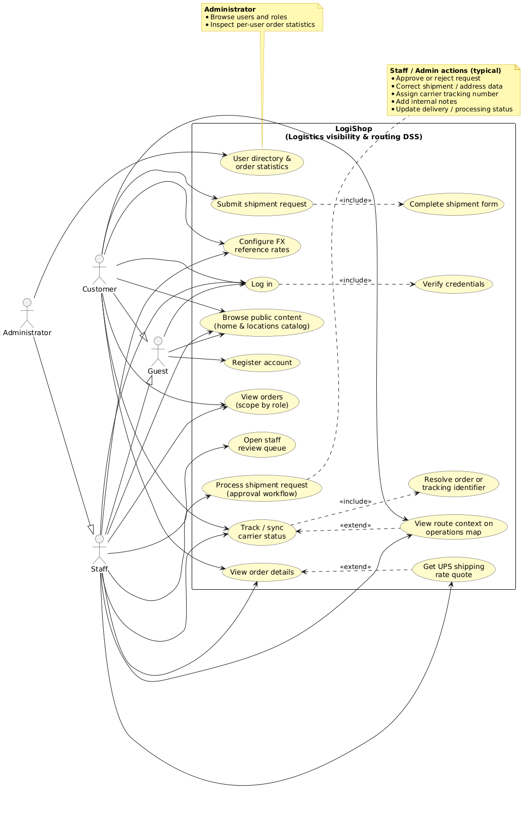
Figure 2: Use case diagram of LogiShop
UC ID | Use Case Name | Primary Actor | Description | Includes | Extends
UC-01 | Register account | Guest | Creates a customer account so the person can submit shipment requests later. | — | —
UC-02 | Log in | Guest, Customer, Staff, Administrator | Authenticates the user and starts a session. | UC-03 | —
UC-03 | Verify credentials | Guest, Customer, Staff, Administrator (supporting) | Checks the identifier and secret against stored credentials; invalid input rejects login. | — | —
UC-04 | Browse public content (home & locations catalog) | Guest, Customer, Staff, Administrator | Read-only access to the marketing home page and facility/location listings without changing operational data. | — | —
UC-05 | Submit shipment request | Customer | The customer sends a new logistics request into the pipeline for staff review. | UC-06 | —
UC-06 | Complete shipment form | Customer (supporting) | Fills origin, destination, package, and routing-related fields required to register the request. | — | —
UC-07 | View orders (scope by role) | Customer, Staff, Administrator | Lists orders: customer sees own approved/visible rows; staff and admin see all orders. | — | —
UC-08 | View order details | Customer, Staff, Administrator | Opens a single order record: status, parties, routing context, and staff-visible extras where allowed. | — | UC-12
UC-09 | Track/sync carrier status | Customer, Staff, Administrator | Refreshes movement and status from the carrier (e.g., UPS) and aligns the order record. | UC-10 | UC-11
UC-10 | Resolve order or tracking identifier | Customer, Staff, Administrator (supporting) | Maps user input (internal order ID or carrier tracking number) to the correct shipment before calling external tracking. | — | —
UC-11 | View route context on operations map | Customer, Staff, Administrator | Optional map-centric view of path/scan context linked to tracking (scope tighter for customers if configured). | — | —
UC-12 | Get UPS shipping rate quote | Staff, Administrator | Optional retrieval of an estimated rate from the UPS Rating service for decision support on the order screen. | — | —
UC-13 | Open staff review queue | Staff, Administrator | Shows pending shipment requests awaiting approval or follow-up. | — | —
UC-14 | Process shipment request (approval workflow) | Staff, Administrator | Approves or rejects the request, edits data, assigns tracking, writes notes, updates processing or delivery status. | — | —
UC-15 | Configure FX reference rates | Customer, Staff, Administrator | Maintains currency conversion factors used when displaying or comparing UPS quotes (UI available to logged-in users in the current build; restrict in text if your policy differs). | — | —
UC-16 | User directory & order statistics | Administrator | Reviews registered users, roles, and aggregated order counts
Description:
This use case diagram shows how each actor might utilize the decision support layer of LogiShop: tracking visibility, shipment requests, staff-based approval, and operational views (operations map). The environmental context note outlines the scope of the use case scenario: global shipping by parcels, tracking by carrier scans (e.g., UPS) showing status and path, reference data stored in the system (list of locations, FX rates to display quotes), and the premise that human operators will make decisions.
Both guests and registered customers (users) have access to the public face of the software system. They can access the locations/catalog/public pages and log in to the software. Every time someone logs into the application, their credentials are always validated against the account database in the system. The guest, who does not have an account, will need to register with the software system (which is beyond the scope of the simplified oval diagram).
Once signed in as a customer, a user can submit a shipment request. That action includes completing the shipment form (origins and destinations, package and routing-related fields, and other inputs your prototype requires) before the request is accepted into the pipeline. After staff processing, the same user can view and track their own orders: they see status and details appropriate to their role. Optionally, they may open the route context on the operations map—an extension of the “view and track” flow when a spatial, map-based reading of movement or planned path is needed.
The administrator takes on all the customer-facing activities in this use case (login, browse, and, assuming that your use case allows for it, the personal shipments and visibility processes as well), but what distinguishes their role is operations management. That includes access to all orders within a broad staff perspective, and not just their own. Platform data and approval processing are part of their responsibilities as well—specifically, this involves managing the approval/rejection workflow, fixing errors in shipment and address data, assigning carrier tracking numbers, documenting staff notes and delivery status, maintaining reference FX rates used when displaying amounts to the user, and the use of the user directory and order statistics to manage accounts and operations. The dotted link from this use case to the context indicates how these responsibilities exist in the broader world of carrier-driven visibility, approval workflows, and reference data quality managed by the DSS system.
Together, the diagram states a compact contract: customers originate requests and consume visibility; administrators (standing in for back-office staff in this abstraction) ** gate, enrich, and administer** the data the DSS needs so that tracking, maps, and decisions remain coherent for everyone who uses the system.

Sequence Diagram

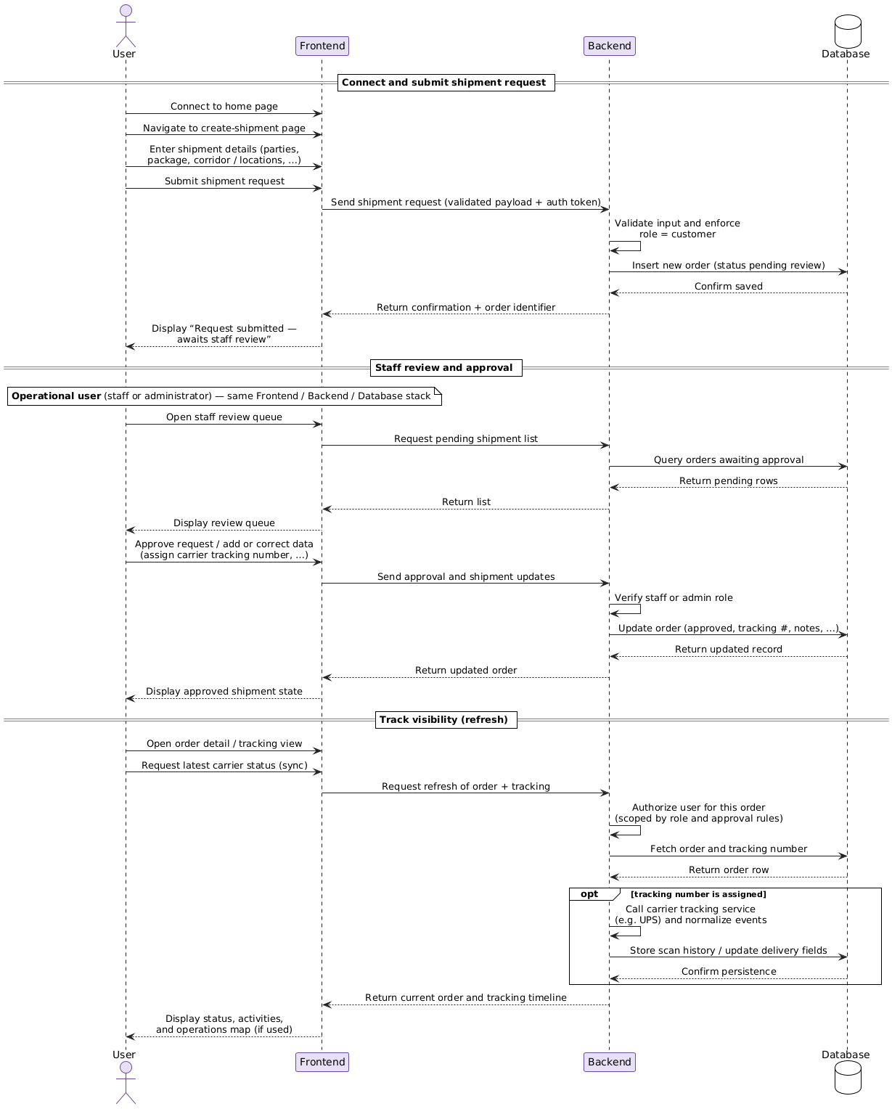

Figure 3: LogiShop Sequence Diagram
The sequence diagram summarizes the end-to-end workflow of the logistics decision-support prototype: how the full stack—User, Frontend, Backend, and Database—works together to capture shipment requests, apply staff governance, pull carrier visibility, and present the result back to the user.

The flow starts when the user opens the home page and moves to the create-shipment area. There, they enter operational inputs (sender and receiver details, package dimensions and weight, corridor or location choices, carrier preference, and related fields). On submit, the Frontend sends a structured request (typically JSON) to the Backend, together with authentication so the server knows who is acting.
The Backend first validates the payload and enforces that only a customer account may open a new shipment request. It then persists the order in the Database in a pending review state (for example, not yet visible in the customer’s normal approved list). The Database acknowledges the write, and the Backend returns a JSON response to the Frontend, which tells the user that the request was accepted and is waiting for staff review.
In the review phase, an operational user (typically staff or an administrator, using the same three-tier stack) opens the review queue in the Frontend. The Frontend asks the Backend for pending rows; the Backend queries the Database and returns a list for display. The reviewer then approves the request, may correct data, and assigns a carrier tracking identifier where applicable. The Backend checks the elevated role, updates the Database, and returns the refreshed order so the Frontend can show the approved state and any new tracking fields.
For track visibility, the user opens the order detail or tracking view and asks for the latest carrier status. The Frontend calls the Backend to refresh the record. The Backend authorizes access according to role and visibility rules (for example, ensuring a customer only sees their own approved orders), reads the order and tracking number from the Database, and, when a tracking number exists, runs an internal carrier step (for example, UPS): it normalizes scan events and writes history or status fields back to the Database. Finally, the Backend returns JSON (current order plus timeline/activity data), and the Frontend presents status, events, and optionally the operations map when that view is used.
Overall, the diagram stresses that the Database is the system of record for orders and tracking-related facts, while the Backend sequences validation, access control, matching business rules to carrier data, and response shaping, so the Frontend can keep the user oriented without exposing unsafe or inconsistent state.

System Design

This section provides the basic blueprint for the foundation of the web application architecture and showing it core objectives, which translate into diagrams and models to help demonstrate the system for development for better understanding.

System Architecture
In this project, Monolith Architecture was used to found the foundation of my web application.

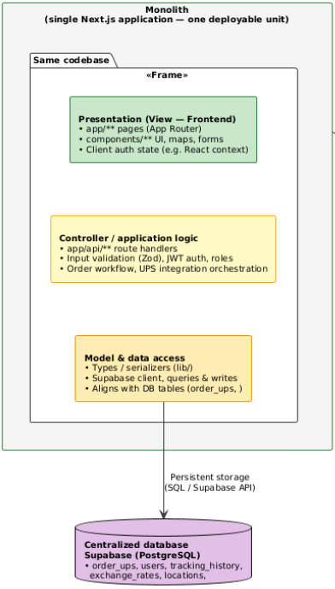
Figure 4: Monolith Architecture

Component | In LogiShop
1. User interface | Next.js App Router pages: home, create-order, orders, order detail, staff queue, operations map, login/register, settings (e.g., FX rates).
2. Application logic | API routes under app/api/...: create/list orders, staff review/approval, refresh/sync tracking, UPS rating, auth login/register, admin user listing.
3. Data access layer | Supabase (and any shared db.get / from('order_ups') patterns), migrations/SQL for schema, serialization to JSON for the UI.
4. Database | PostgreSQL via Supabase — e.g. order_ups, users, tracking_history, exchange_rates, locations, etc.
5. External dependencies | UPS Developer APIs (tracking, rating/OAuth), possibly geocoding or map provider as used in the map UI—invoked from your backend routes, not separate microservices you own.
6. Middleware / cross-cutting | Next.js middleware if you use it; JWT authentication, rate limiting on login, input sanitization/validation (Zod), logging, and error handling in API routes.

Design Pattern
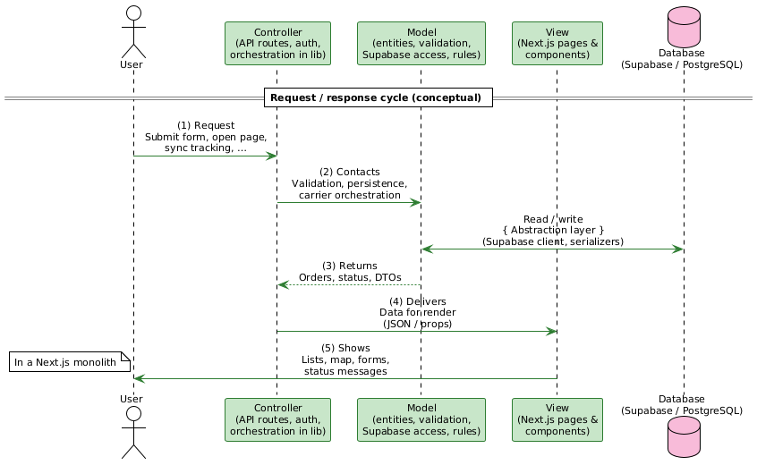

To make the codebase easier to manage and maintain, this project is described using the Model-View-Controller (MVC) pattern. MVC splits concerns into Model, View, and Controller, which supports localized changes (for example, tightening validation or refreshing a screen) without unnecessarily destabilizing the rest of the system. Used as a structuring idea, MVC also keeps the thesis implementation organized and the responsibilities of each layer explicit.

Development Environment and Technology Stack

LogiShop was implemented by using JavaScript/TypeScript for the high demand of iteration, maintainability, and deployment feasibility.

Next.js, React, and TypeScript were used at the application framework level to facilitate a robust component-based user interface and API processing based on routes.
Tailwind CSS was used at the styling level to develop a responsive dashboard interface consisting of an operations panel, a map pane, an input form, and a status bar. Using Tailwind CSS can reduce the development of custom CSS styles and maintain consistent style throughout the user interface.
Supabase PostgreSQL was used at the data layer level to store data for the order and tracking processes. SQL schema files were developed to construct a schema for order and tracking data. Supabase was selected because it combines the benefits of PostgreSQL and cloud-based services with Next.js API functionalities.
Leaflet and react-leaflet were utilized at the visualization level to display maps using polylines, overlays, and map controls to enable the rendering of maps without conflicts between client-side and server-side mapping libraries.
Tracking synchronization was accomplished by integrating UPS API tracking data. The web-based application could access and retrieve orders and tracking data from UPS APIs to compare the costs of different routes.
Token generation based on JWT, password encryption, rate limiting utilities, and validation/sanitization were applied in the authentication and security layer.

Layer | Technology | Purpose | Why selected
Frontend | Next.js, React, TypeScript | Construct dashboard UI, tracking components, routing controls, and client state management. | Next.js allows full-stack architecture; React works well with components; TypeScript enhances type safety for shipments.
UI Styling | Tailwind CSS | Create responsive layout, tabs, cards, forms, and map containers | Less overhead, faster UI, consistent design
Backend/API | Next.js Route Handlers | REST endpoints for auth, orders, routes, tracking, and sync | Combine frontend and backend in one codebase for easier deployment
Database | Supabase PostgreSQL | Store order details, location, tracking, and history records | PostgreSQL reliability, SQL flexibility, and easy integration with Next.js
Auth/Security | JWT, bcryptjs, custom rate-limit utility | Token-based login, password hashing, brute-force/DDoS-style endpoint protection | Lightweight security baseline for a web application
Map/Geospatial | Leaflet + react-leaflet | Render transportation map, markers, routes, overlays | Comprehensive map system, easy polyline and marker customization
Geocoding | Custom geocoding.ts + cached airport lookup + fallback geocoder | Transform text locations and ports to coordinates for route plotting | A combination of approaches leads to better performance and reliability due to the wide variation of global locations
External Integration | UPS Tracking API (ups-tracking.ts) | Fetch real-time update from carriers | Carrier synchronization
Rate limit | Limit requests from the user endpoint | Validate request and eliminate DDoS vulnerabilities | Prevents malicious and overloaded web applications
Disruption Routing | Custom graph module (disruption-router.ts) with Dijkstra | Detect blocked routes and compute a reroute path | Identify blocked routes and calculate a new path
Table 1: Technology Stack Used in LogiShop

Database design
- Database model
The database implementation is designed to help with shipment lifecycle tracking rather than keeping only static orders. The schema contains order records, tracking-related records, and location and ports.

Table | Description | PK | Attributes (excluding PK/FK) | Rules & constraints | Relationships
users | Stores registered accounts and roles for authentication and authorization. | id (UUID) | email, password, name, phone, address, role, created_at | email unique; password policy enforced in application layer; role distinguishes customer/staff/admin | users → order_ups: optional 1:M (owner of shipment requests). users → order_ups: optional 1:M as reviewer (reviewed_by) after approval migration.
order_ups | Primary shipment table: parties, corridor, package data, workflow, carrier linkage, and fields updated from tracking sync. | id (UUID); business key order_id (unique) | user_id, unique_id_user, sender/receiver fields, dimensions/weight, from_location, to_location, origin, destination (JSONB where used), status, delivery_status, tracking_number, carrier, submission_time, approval_status, staff_notes, reviewed_at, extended_data (JSONB), timestamps such as tracking_last_fetched / latest_tracking_update where present | order_id unique; approval_status constrained to allowed values (e.g., pending review / approved/rejected); weights and addresses required by application validation; tracking-driven updates coexist with staff-controlled status | order_ups → users: optional M:1 (user_id / unique_id_user). order_ups → tracking_history: optional 1:M. order_ups → users: optional M:1 (reviewed_by).
tracking_history | Append-only-style carrier activity timeline (UPS scans) for map and audit views. | id (UUID, typical) | order_id, tracking_number, activity_date, activity_time, activity_datetime, location fields (location_full, …), status_type, status_description, carrier, source, raw_data (JSONB) | De-duplication logic in service layer (same order + date + time); source marks UPS API | tracking_history → order_ups: mandatory M:1 (order_id).
locations | Master list of airports, seaports, and storage nodes for maps and operations screens. | id (UUID) | name, type (storage/airport/seaport), latitude, longitude, address, city, country, description, timestamps | type check constraint in base schema | No mandatory FK from order_ups (endpoints often stored as labels on the order); logical use for map layers and filtering.
products | Demo catalog used by the storefront-style areas of the monolith. | id (UUID) | name, description, price, image, category, stock, rating, reviews, created_at | price, stock, numeric integrity | Standalone catalog; no required FK to shipments in the logistics core.
exchange_rates | Monthly (or period-based) FX reference for displaying UPS quotes in a local currency context. | Composite / id (per your deployment) | period, currency_from, currency_to, rate_per_usd, source, updated_at | Unique tuple (period, currency_from, currency_to) in typical designs | Standalone reference data; consumed by rating/quote UI, not embedded in order_ups rows.
raw_orders | Staging/import table for legacy spreadsheet or CSV pipelines (wide column set). | id (SERIAL) | many operational columns (e.g., house_bill_no, hub, dates, weights, addresses, surcharges, …) | house_bill_no unique in template schema | Logical upstream of order_ups in ETL scenarios; relationship implemented in import jobs, not necessarily declarative FKs.
order_ups_summary | Database view: flattened subset of order_ups for quick listing. | — (view) | columns selected in the view definition | Read-only | View of order_ups: virtual 1:1 with underlying row.

Table 2: Main Database Tables
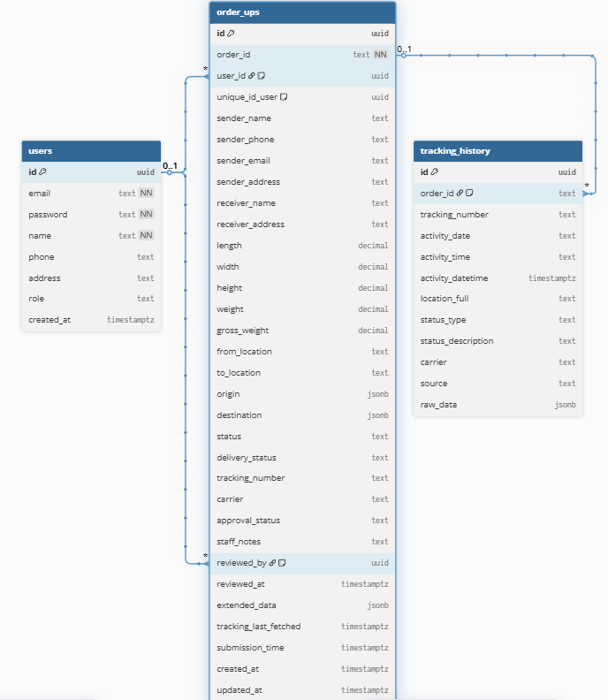

Figure 5: ERD of LogiShop
b. Relationship
1. users → order_ups (customer)
- Link: users.id = order_ups.user_id
- Cardinality: one user to many orders (each order row has at most one owning customer row).
- Meaning: A registered user can submit several shipment requests over time. Each order_ups row is tied to one account via user_id, which supports listing “my orders,” access control, and scoping what each customer can see after approval rules are applied.
2. users → order_ups (reviewer/staff)
- Link: users.id = order_ups.reviewed_by
- Cardinality: one staff user to many reviewed orders; each order can have at most one reviewer on file (reviewed_by may be null until someone acts).
- Meaning: This is the operational / governance side of the same order_ups table. When staff approve, reject, or annotate a request, the system can record who did it and when (reviewed_at). It does not replace the customer link: one row uses two optional roles of users—placer (user_id) and reviewer (reviewed_by).
3. order_ups → tracking_history (shipment timeline)
- Link: order_ups.order_id = tracking_history.order_id (business key, not necessarily order_ups.id)
- Cardinality: one order to many tracking events; each history row belongs to one order.
- Meaning: As the carrier reports scans (pickup, hub, out for delivery, etc.), the application appends rows in tracking_history. That gives you a chronological trail for dashboards, audit, and map-style views, separate from the current summary fields kept on order_ups (e.g., latest status hints, tracking_last_fetched).

User Interface (UI) design

The objective of UI design in the case of the system is a website that is clean and accessible. It should allow customers to order shipments and track them without undergoing any kind of training process. The website has several pages where the navigation bar helps find pages like the home page, orders, price rates, etc. The form used by users is very simple.

Algorithm design

This section highlights the primary algorithmic concepts used to develop the decision-support prototype. These are not based on any particular “score every destination” recommendation but rather enable shipment governance, carrier visibility, and rerouting upon disruption.

Request validation and access control
Before any business logic runs, structured inputs (shipment requests, staff review payloads, tracking refresh calls) pass through schema validation and authentication. Invalid payloads are rejected early, so downstream steps operate on consistent types and sanitized strings. Authorization combines role (customer, staff, administrator) with row-level rules (for example, whether a customer may see a request before staff approval). This is an O(1) or O(n) check per request relative to the size of the rule set.
Carrier tracking, merging, and timeline construction
When a tracking order exists, the system retrieves scan-level events from the carrier service, then:

- Normalizes each event into a common shape (timestamp fragment, location label, status text).
- Orders events chronologically so “oldest → newest” reflects true movement (carrier feeds may arrive in reverse order).
- De-duplicates inserts so the same scan date/time is not stored twice for the same order.
- Derives auxiliary views for the UI: for example, a compact location path (unique hubs in sequence) and hints for origin vs latest scan labels.
- The highest cost is typically linear in the number of activities for that shipment, O(k), plus database I/O. This algorithm is explanatory rather than prescriptive.
Route replanning with Dijkstra’s algorithm (disruption scenario)
For the thesis demonstration of routing under constraints, the client-side logistics module builds a graph of hubs and edges (connections with weights such as distance or cost in the model). When a disruption zone blocks part of the network, the system can run Dijkstra’s shortest-path algorithm on that graph to obtain a minimum-cost path between a start hub and an end hub subject to blocked edges.

- Input: nodes (hubs), weighted edges, optionally removed or penalized edges representing disruptions.
- Output: an ordered list of hubs forming an alternative corridor and an aggregate cost/length measure for comparison with a baseline path.
- Complexity: with a binary-heap style priority queue, Dijkstra is O((V + E) log V) over vertices V and edges E for nonnegative weights; the demo graph is kept small so response times stay interactive.

CHAPTER 4

IMPLEMENTATION AND RESULTS

Implementation

Overview
The implementation of LogiShop was performed in gradual stages, with each stage gradually transforming the system from a data-driven web application into an international shipping management platform.
The infrastructure level, the system was built by using Next.js and React frontend with TypeScript, a route-handler-oriented backend in the same project, with Supabase database, and PostgreSQL data layer. This technical stack helps reduce integration overhead and support full-stack iteration.
The first milestone focuses on the core API and readiness. At this stage, the goal is to create stable data connections for orders and route records in order for the frontend modules to rely on a predictable response. Endpoints for authentication, fetching orders, and route retrieval were implemented early, and the database schema was also prepared at this stage to ensure a reusable setup.
Once the backend foundation is established, the development phase focuses on the mapping system module, which is the main user-facing component of the system. The map implementation introduces route rendering based on the from-to destination of the database.
A disruption handling system was implemented to support route and decision support on the economic side. In the module, disruption events can be created through the interface and converted into a geographic impact zone by staff. The system can re-route a blocked path to an alternative route using graph-based and shortest-path algorithm logic. When implemented, the system would enable users to visually determine whether their path was blocked or rerouted, thus providing them with information about both their status and a possible way forward. It thereby transformed LogiShop from being a mere tracking dashboard to a planning support system.
International shipping also faces challenges: delayed or outdated tracking information, such as the UPS tracking system, generally deletes its old tracking data 120 days from the day the shipment was created. Other issues include limited geographic content, severe disruption caused by natural disasters, geopolitical conflicts (war zones), port congestion, and other unpredictable events. LogiShop was designed as a solution to solve these difficulties, but not as large-scale as incorporation.
The chapter is structured around key application areas. For each, it identifies a core logistics problem, describes how LogiShop’s features are applied in practice, and discusses the observed results supported by implementation testing. Specially emphasize the disruption handling to redirect the route when a disruption area occurs.

Code Implementation
- Project Structure
Frontend: Frontend. The front-end part of the system is organised for modularity, scalability, and readability. The frontend directory groups shared presentation code: components, subdivided into layout (e.g., navigation and footer), maps (map views and operations overlays), and tracking (carrier tracking widgets), and contexts, which hold AuthContext and other React context providers for cross-page client state (such as authentication after login). Actual screen-level composition is not under a classic src/pages tree with main.jsx; instead, Next.js (App Router) uses the app directory at the project root, where each route folder contains a page.tsx (and optional layouts). Shared TypeScript/React files use the .tsx extension. Static assets served unchanged are kept in public at the project root. Import paths use the project’s tsconfig aliases (e.g., @/components/..., @/contexts/...) so pages can stay thin while reusing the UI modules under frontend.

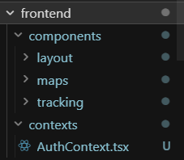

Backend: The server side is structured so that HTTP handling, domain logic, and persistence remain maintainable as the application grows. REST-style HTTP handlers live under app/api: each subfolder corresponds to a URL segment (e.g., auth, orders, locations, UPS proxies). They validate input, call shared services, and return JSON—conceptually similar to routes + controllers in a separate Express service, but integrated with Next.js. Reusable business logic, data access, validation, role checks, carrier integration (UPS), and auxiliary algorithms (including disruption / rerouting logic) are concentrated under backend/lib. That tree also includes supabase helpers for the database client and seed data for bulk CSV/JSON used by seeding routes (e.g., airport locations). The live database is PostgreSQL via Supabase, not MySQL with Sequelize; schema and migrations are maintained under the top-level supabase directory. middleware.ts at the project root participates in request processing (e.g., session refresh). Utility-style code—errors, auth tokens on the client, API helpers—lives in backend/lib modules referenced from both app/api and the React client, rather than in a separate legacy utils folder on the server. There is no standalone server.js: the framework runtime starts the app, and app/api route modules act as entry points for each endpoint.

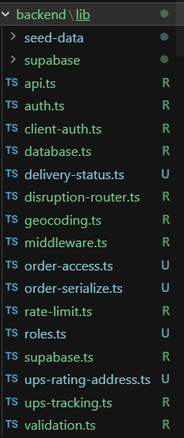

- Algorithm

Main workflow:

function findReroute(fromLat, fromLng, toLat, toLng, disruptions, options):
Try:
hubs ← options.hubs ?? LOGISTICS_HUBS
edges ← options. edges ?? RAW_EDGES

startHub ← nearest hub to (fromLat, fromLng) on hubs
endHub ← nearest hub to (toLat, toLng) on hubs

blocked ← directRouteBlocked(fromLat, fromLng, toLat, toLng, disruptions)

{ path, totalKm } ← dijkstra(startHub.id, endHub.id, disruptions, hubs, edges)

waypoints ← [ hub record for each id in path ]

directKm ← haversine(fromLat, fromLng, toLat, toLng)
detourKm ← totalKm - directKm
detourPct← (detourKm / directKm) * 100 (if directKm > 0)

Return { waypoints, totalDistanceKm: totalKm, blocked, metrics: { … } }
Catch error:
Log error
Return appropriate failure to the caller
Table 3: findReroute() Psuedo code

findReroute loads the default hub list and edge list (or accepts overridden lists for benchmarking). It snaps the user’s origin and destination coordinates to start and end hubs via nearest-neighbour (Haversine distance). It sets blocked if the direct great-circle arc from origin to destination intersects any disruption footprint (sampling along the shorter antimeridian-aware arc), which matches what is drawn as the “direct” line on the map. It then calls Dijkstra (startHub, endHub, …), which minimises total edge weight along allowed links. Returned metrics include directDistanceKm (great circle), detourKm = path length minus that direct distance, and detourPct.

function edgeWeight(edge, hubById, disruptions):
a ← hubById[edge.from]; b ← hubById[edge.to]
multiplier ← 1

For each disruption d in disruptions:
If hub a or b inside d.bbox OR arc(a → b) intersects d.bbox (sampled):
If d.severity is high or critical:
Return infinity // hard block
Else:
multiplier ← max(multiplier, severityMultiplier[d.severity])

Return edge.distanceKm * multiplier
Table 4: edgeWeight (conceptual pseudo-code)

Each edge’s weight is edgeWeight(edge) = distanceKm × multiplier, where multiplier starts at 1. For every active disruption, the implementation tests whether the edge should be penalised: a hub lies inside the zone, or the great-circle segment between the two endpoints samples into the bounding box. For low/medium severity, the edge may be penalised by a finite multiplier. For high/critical severity, the weight becomes infinity—the edge is removed from the usable graph, modelling “do not traverse this lane through a war/closure / severe hazard zone.” Dijkstra therefore yields a shortest feasible path among non-blocked edges, not merely any connected path.

function dijkstra(startId, endId, disruptions, hubs, edges):
Build an undirected adjacency from edges (both directions)
Initialise dist[all hubs] ← infinity; dist[startId] ← 0
Priority queue ← { (startId, 0) }

While the queue is not empty:
Pop hub u with the smallest dist[u]
If u == endId: break
For each neighbour v via edge e:
w ← edgeWeight(e, …)
If w is infinity: continue
If dist[u] + w < dist[v]:
dist[v] ← dist[u] + w; predecessor[v] ← u

Reconstruct path from endId back along predecessor
Return { path, totalKm: dist[endId] }

Table 5: dijkstra (conceptual pseudo-code)

Results

Home Page / Landing Page

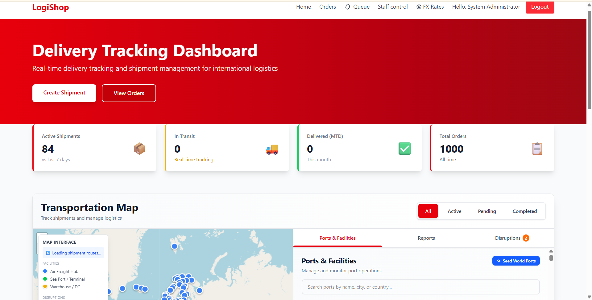
Figure 6: Home Page

The homepage serves as the initial page after logging in and as the landing page. It is laid out to provide clarity and usability, meaning that at first glance, the user must have a clear idea of what the app does and what to do next. A hero block highlights the positioning using a main heading ("Delivery Tracking Dashboard") and a small caption, where users will understand the scope of real-time shipment tracking and international logistics management. Beneath this text are two call-to-action elements: one that sends the user to create shipments, and another to view orders in the list format. At the bottom of the hero block is a metrics bar featuring relevant KPIs (such as active shipments, in-transit shipments, deliveries month-to-date, and total number of orders ever). The section below comprises the transportation map and its associated panel. Here, users can filter the transportation according to status (All/Active/Pending/Completed), examine facilities and ports, optionally access the report, and launch the Disruptions dashboard to aid in the decision-making process. Finally, a persistent navigation bar (branding, primary module links such as orders and staff workflows, exchange-rate utilities where enabled, and session actions) provides consistent orientation across the rest of the application, matching the role-based structure described elsewhere in the chapter.

    - Input Form

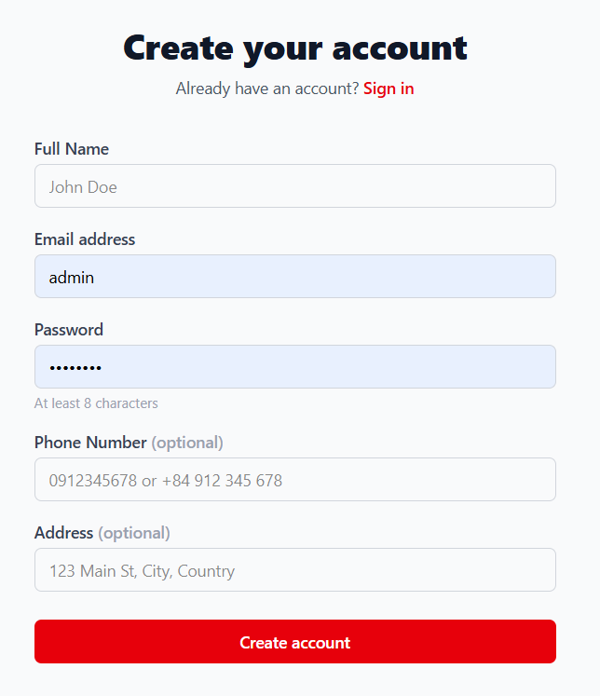
Figure 7: Create Account Form
The Create account screen is the registration entry point for LogiShop: it collects the minimum identity data needed to provision a customer account and later associate orders and tracking activity with a unique user. The interface is presented as a single-column form on a neutral background, so attention stays on the task. At the top, a primary heading (“Create your account”) states the page goal, and a secondary line invites users who already have credentials to open the Sign in view via an inline link, reducing dead-end friction for returning visitors.
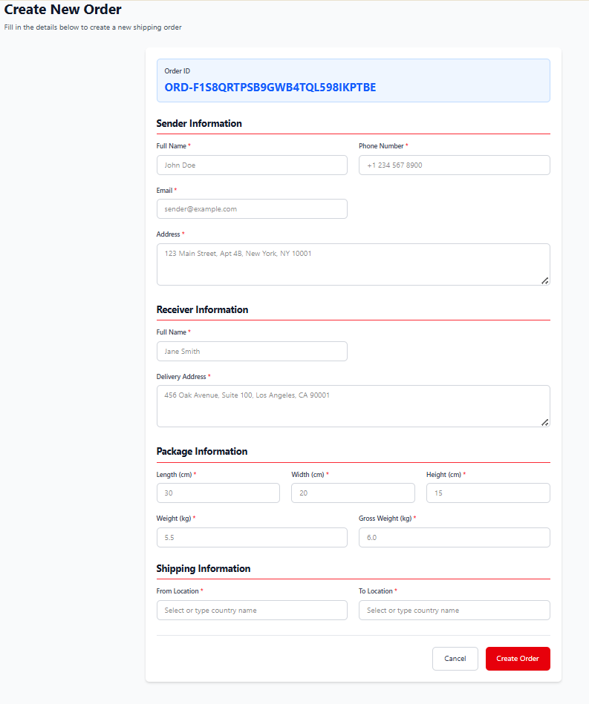
Figure 8: Create Order Form
The Create Order Form is where the user/customer can input their information for the delivery they want. There are validation requirements in order for the user to input so as not to damage the database and give the operators accurate information to process the delivery.

Data Synchronization and Fresh Tracking Context
One of the biggest challenges of logistics for international shipping is tracking orders. Operators frequently deal with enormous amounts of data and manually check multiple carriers' systems.
This feature directly solves the problem of fragmented and outdated tracking information and gives users a solution to receive all necessary information regarding their shipments.
Implementation and testing showed that the synchronization workflow significantly improves tracking freshness and consistency. One-click tracking can reduce manual efforts and help consistency monitoring of international packages.
Figure 9 shows the staff/admin UI view that will approve the delivery from the user/customer. Figure 10 shows the compacted view of the order when the order has been approved by staff/admin.

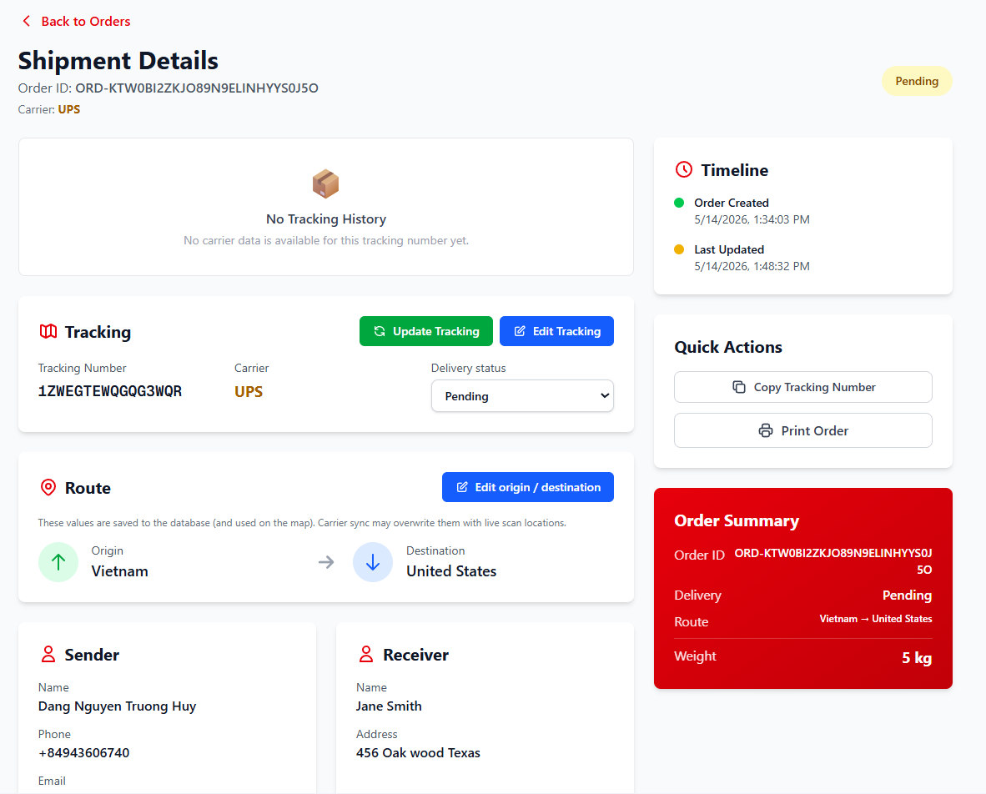

Figure 9: Detailed tracking panel with timeline of staff/admin

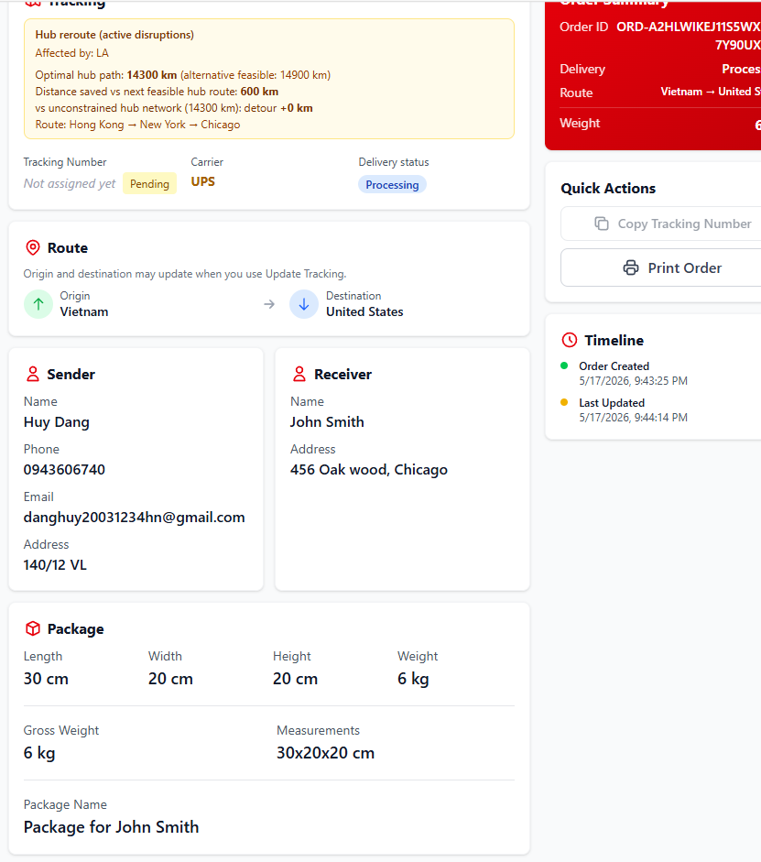

Figure 10: Package information from the customer view

Route Visualization and Disruption-Aware Rerouting (Core Application)
Problem: International shipments are highly vulnerable to major disruptions such as war zones, natural disasters, geopolitical conflicts, and extreme weather. The traditional system lacks the ability to visualize a clear alternative suggestion route when a problem occurs.
Application of LogiShop:
The system first geocodes origin and destination data to render shipment routes as colored polylines on a mapping system. Staff can register disruption events through the interface, and when a user creates a shipment containing a date that goes through the severity zones, it will automatically notify them and apply a graph-based shortest path algorithm calculated to display an alternative route for the user [8].
Results and Objective Fulfillment:
Map visualization greatly enhances users’ understanding of package movement across countries. Most importantly, the algorithm reroute function successfully acknowledges the blocked zones and routes to generate feasible alternatives in simulated disruption scenarios. Therefore, improving resilience and supporting better decisions for international logistics.
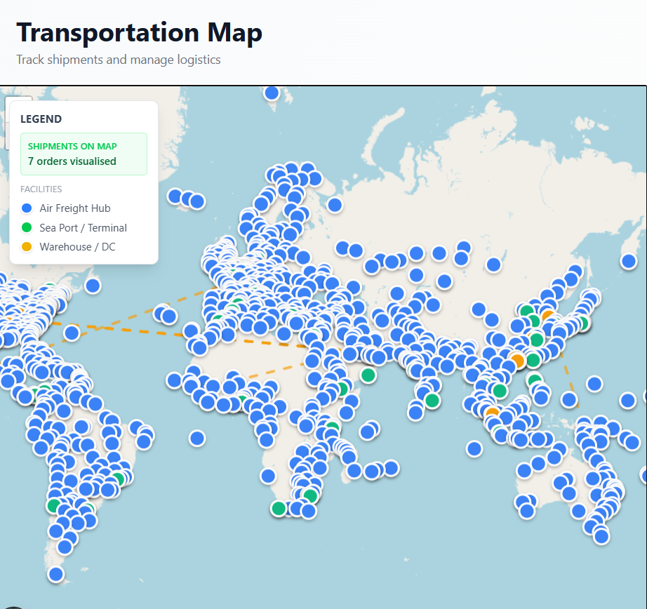

Figure 11: TransportationMap Main Interface

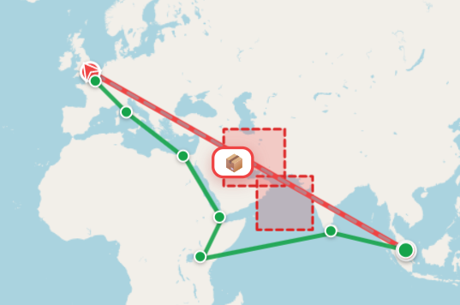

Figure 12: Disruption Zone and Rerouted Path Visualization

Security Measures in Operational Use
A critical requirement for any logistics platform is the protection of its APIs, especially for handling package tracking and disruption-handling rerouting decisions. Those are vulnerable to various threats and brute-force attacks, excessive request abuse, and malicious input injection that can endanger the system's security.
In Logishop, security is implemented through practical layers at the API level. Rate limit is applied to prevent abuse and brute-force attempts. All user inputs undergo validation and sanitization before being processed in the database. During testing, the security measurements performed effectively, and the rate limit successfully prevented excessive requests.
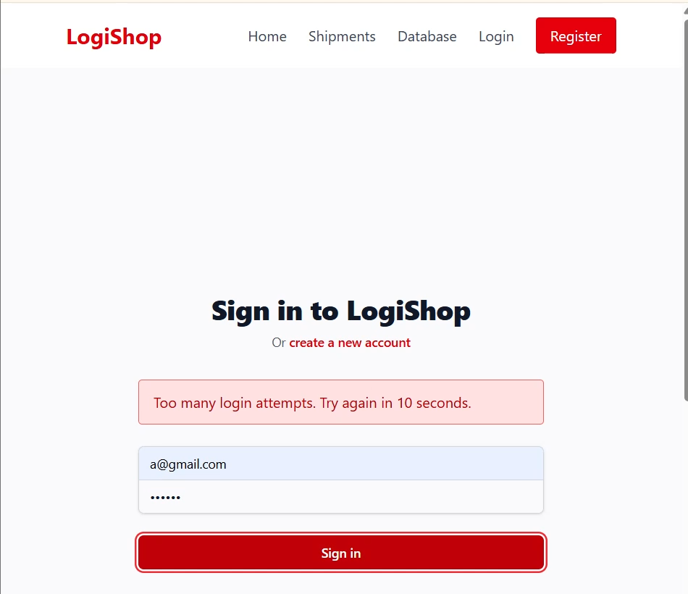

Figure 13: Rate limit test result HTTP 429

Consolidated Results and Achievement of Thesis Objectives
Application Area | Logistics Problem Addressed | How LogiShop is Applied | Key Results Achieved | Thesis Objective Fulfilled
Authentication | Unauthorized access | JWT token-based login | Secure access to all features | Secure platform foundation
Package Tracking & Synchronization | Outdated tracking information | One-click refresh + UPS integration | Fresher, consistent package visibility | Reliable tracking
Workflow Integration | Fragmented operations | Seamless search–track–visualize workflow | Reduced manual work, better user experience | Practical usability
Route Visualization | Lack of geographic insight | Interactive geocoded map | Clear understanding of package routes | Enhanced visibility
Disruption Handling & Rerouting | Inability to respond to war zones, disasters, etc. | Disruption detection + graph algorithm rerouting | Successful alternative routes generated and visualized | Core thesis objective
Security | API abuse and vulnerabilities | Rate limiting + validation/sanitization | Protected tracking and rerouting functions | System reliability

Table 6: Consolidated Results and Achievement
In summary, the applications and results of LogiShop clearly demonstrate that the platform successfully achieves its intended purposes. Providing an effective tracking system while preventing any threats that cause harm to the database and users.

4.3.2. Algorithm Efficiency

 | Scenario | Disruptions | Runs | Success Rate  % | AvgMs | MinMs | maxMs | stdDevMs | Avg Distance Km | Avg Reroute%
0 | 'D0' | 0 | 30 | '100.00' | '0.174' | '0.111' | '0.308' | '0.049' | '11050.00' | '1.86'
1 | 'D1' | 1 | 30 | '100.00' | '0.218' | '0.119' | '0.827' | '0.127' | '13150.00' | '21.22'
3 | 'D3' | 3 | 30 | '0.00' | '0.360' | '0.165' | '2.921' | '0.532' | '0.00' | '0.00'
2 | 'D2' | 2 | 30 | '100.00' | '0.405' | '0.150' | '5.534' | '0.959' | '13150.00' | '21.22'
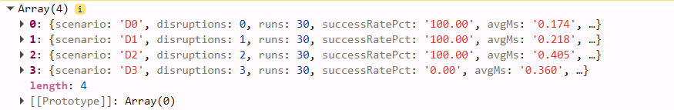

Figure 14: Dijkstra 30 runs
Across 30 runs per scenario, the disruption-handling Dijkstra implementation remains efficient, with average execution time below 1 ms in all scenarios. As disruption constraints increase from D0 to D2, the success rate is maintained at 100%. In D3, the success rate dropped to 0%, showing that under the current network and disruption combination, no feasible path exists.
 | Extra hubs | Nodes | Edges | Scenarios | Disruptions | Runs | Success Rate % | avgMs | Min ms | Maxms | Std Dev Ms | Avg Distance Km | Avg Reroute %
0 | 0 | 42 | 95 | 'D0' | 0 | 500 | '100.00' | '0.3326' | '0.0680' | '38.0915' | '2.1425' | '11050.00' | '1.86'
1 | 0 | 42 | 95 | 'D1' | 1 | 500 | '100.00' | '0.1427' | '0.0857' | '1.2188' | '0.1177' | '13150.00' | '21.22'
2 | 0 | 42 | 95 | 'D2' | 2 | 500 | '100.00' | '0.1621' | '0.1044' | '0.7952' | '0.1054' | '13150.00' | '21.22'
3 | 0 | 42 | 95 | 'D3' | 3 | 500 | '0.00' | '0.2399' | '0.1466' | '1.6697' | '0.1646' | '0.00' | '0.00'
4 | 60 | 102 | 155 | 'D0' | 0 | 500 | '100.00' | '0.3747' | '0.1380' | '2.8148' | '0.3683' | '11050.00' | '1.86'
5 | 60 | 102 | 155 | 'D1' | 1 | 500 | '100.00' | '0.3731' | '0.1623' | '2.1832' | '0.2524' | '13150.00' | '21.22'
6 | 60 | 102 | 155 | 'D2' | 2 | 500 | '100.00' | '0.5905' | '0.2114' | '38.3512' | '2.1521' | '13150.00' | '21.22'
7 | 60 | 102 | 155 | 'D3' | 3 | 500 | '0.00' | '0.5046' | '0.2601' | '1.9221' | '0.2241' | '0.00' | '0.00'
8 | 120 | 137 | 190 | 'D0' | 0 | 500 | '100.00' | '0.4445' | '0.2197' | '3.0958' | '0.3105' | '11050.00' | '1.86'
9 | 120 | 137 | 190 | 'D1' | 1 | 500 | '100.00' | '0.3906' | '0.2503' | '2.1270' | '0.2056' | '13150.00' | '21.22'
10 | 120 | 137 | 190 | 'D2' | 2 | 500 | '100.00' | '0.5937' | '0.2593' | '3.3932' | '0.3707' | '13150.00' | '21.22'
11 | 120 | 137 | 190 | 'D3' | 3 | 500 | '0.00' | '0.6778' | '0.3444' | '2.4191' | '0.3080' | '0.00' | '0.00'
12 | 200 | 137 | 190 | 'D0' | 0 | 500 | '100.00' | '0.6188' | '0.1811' | '26.7569' | '1.8476' | '11050.00' | '1.86'
13 | 200 | 137 | 190 | 'D1' | 1 | 500 | '100.00' | '0.3775' | '0.2027' | '2.4686' | '0.2244' | '13150.00' | '21.22'
14 | 200 | 137 | 190 | 'D2' | 2 | 500 | '100.00' | '0.5004' | '0.3091' | '3.3693' | '0.2752' | '13150.00' | '21.22'
15 | 200 | 137 | 190 | 'D3' | 3 | 500 | '0.00' | '0.5833' | '0.3731' | '2.1557' | '0.2344' | '0.00' | '0.00'
16 | 300 | 137 | 190 | 'D0' | 0 | 500 | '100.00' | '0.4489' | '0.2129' | '4.6925' | '0.3310' | '11050.00' | '1.86'
17 | 300 | 137 | 190 | 'D1' | 1 | 500 | '100.00' | '0.3612' | '0.2201' | '1.6650' | '0.1553' | '13150.00' | '21.22'
18 | 300 | 137 | 190 | 'D2' | 2 | 500 | '100.00' | '0.5133' | '0.2801' | '2.9931' | '0.2652' | '13150.00' | '21.22'
19 | 300 | 137 | 190 | 'D3' | 3 | 500 | '0.00' | '0.5743' | '0.3719' | '3.2956' | '0.2843' | '0.00' | '0.00'

Table 7: Dijkstra 500 runs
Across 500 repeated runs per scenario, the disruption-handling Dijkstra implementation demonstrates stable performance under increasing graph complexity from 30 runs. The execution time remains low with acceptable variance. The percentage of success remains similar to the previous test case.

4.3.3. Operational & Economic Value
One of the main objectives of LogiShop is to reduce the operational burden placed on small and medium-sized enterprises (SMEs). The priority of the business is still cost-effectiveness and reducing time consumption and workload of both users and operators.
To quantify the improvement delivered by LogiShop, a structured workflow comparison was conducted to measure the number of user interactions and the total time required to complete a standard shipment monitoring task.
Step | Action | Platform | Clicks | Time (min)
1 | Log in to the carrier tracking platform | UPS.com | 2 | 1.0
2 | Enter tracking number and submit query | UPS.com | 3 | 2.0
3 | Read the activity table and note the latest known city | UPS.com | 5 | 4.0
4 | Open news sites and port-authority pages to check for active disruptions | Browser / News | 6 | 8.0
5 | Cross-reference the disruption area against the shipment route (manual) | Browser / Mental | 4 | 5.0
6 | Search for and compare alternative routing options | Browser / Freight forums | 7 | 15.0
7 | Record the updated routing decision and share with the team | Spreadsheet / Email | 3 | 3.0
Total |  |  | 30 | 38.0

Table 8: Fragment workflow

Step | Action | Clicks | Time (min) | Step
1 | Log in to LogiShop | 2 | 0.5 | 1
2 | Navigate to the Transportation Map, enter Order ID, and click Track | 1 | 0.5 | 2
3 | View live status, route visualisation, and package icon on the map (automatic) | 0 | 0.0 | 3
4 | Switch to the Disruptions tab and verify active disruption zones | 1 | 0.5 | 4
5 | View the automatically computed rerouted path on the map | 0 | 0.0 | 5
6 | Copy Order ID or take a screenshot for internal record | 1 | 1.0 | 6
Total |  | 5 | 2.5 | Total

Table 9: LogiShop workflow

4.3.4.1 Comparative Analysis

Metric | Fragmented Workflow | LogiShop | Reduction
Total clicks/interactions | 30 | 5 | ↓ 83%
Total time per task (min) | 38.0 | 2.5 | ↓ 93%
Platforms visited | 4+ | 1 | ↓ 75%
Manual disruption evaluation steps | 11 | 0 | ↓ 100%
Table 10: Workflow comparison
As demonstrated in Table 10, LogiShop reduces the number of manual interactions by 83% and the total task completion time by 93%. The most significant aspect that can be observed is that disruption-handling and evaluation are automatically performed by the web application.

4.3.4.2. Cost Impact
A central objective of LogiShop is to deliver measurable financial benefit to small and medium-sized enterprises (SMEs) by enabling early detection of supply chain disruption and calculating the cost-optimal alternative route by using rules of carriers [8].
The analysis uses a UPS international shipment tracking number 1ZB8678F6735719517 from Vietnam delivered to the United States, calculating price based on specifications retrieved via the UPS Tracking API and the price quote obtained via the UPS Rating API.
Field | Value
Dimensions | 10 × 20 × 20 cm
Actual weight | 5 kg
Gross weight | 6 kg
Origin | Vietnam (VN)
Destination | United States (US)
Carrier | UPS

Field | Value | Source
Dimensions | 10 × 20 × 20 cm | UPS Tracking API
Actual weight | 5 kg | UPS Tracking API
Gross weight | 6 kg | UPS Tracking API
Origin | Vietnam (VN) | UPS Tracking API
Destination | United States (US) | UPS Tracking API
Carrier | UPS | UPS Tracking API
Service | UPS Worldwide Expedited | UPS Rating API
Quoted price (VND) | 7,488,072 VND | UPS Rating API (live quote)
Quoted price (USD) | $294.81 USD | Converted at 25,400 VND/USD (May 2026)

Table 11: Package 1ZB8678F6735719517
UPS Determine billable weight:

Dimensional Weight = (Length × Width × Height) / 5,000
= (10 × 20 × 20) ÷ 5,000
= 4,000 / 5,000
= 0.8 kg

Billable weight = max (actual 5 kg, dimensional 0.8 kg)
= 5 kg
Price from UPS Rating API:
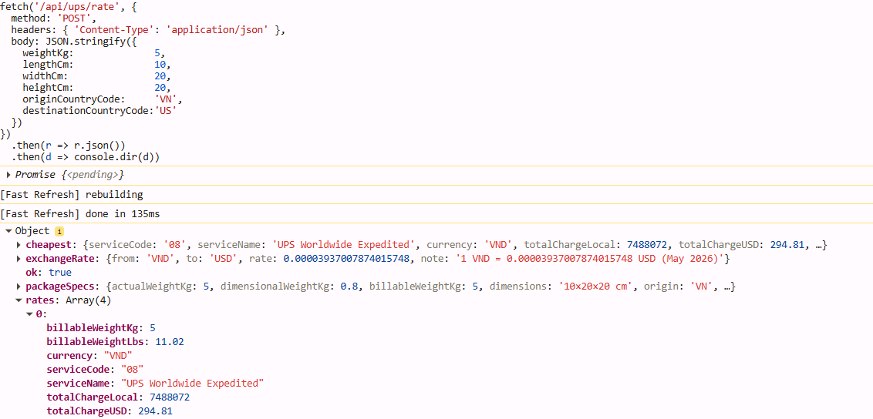
Figure 15: UPS Freight data of 1ZB8678F6735719517
The price was obtained directly from the UPS Rating API using the exact package specifications of tracking number 1ZB8678F6735719517. The API returned the following quotes for all available international services.
Service | UPS Service Code | Price (VND) | Price (USD)
UPS Worldwide Expedited | 08 | 7,488,072 | 294.81
UPS Worldwide Saver | 65 | 10,755,893 | 423.46
UPS Worldwide Express | 07 | 11,395,287 | 448.63
UPS Worldwide Express Plus | 54 | 12,798,237 | 503.87
Table 12: UPS Freight cost of 1ZB8678F6735719517
Disruption Scenarios and Result
Scenarios were defined to represent assumptions about geopolitical and environmental disruption conditions observed in major international shipping corridors:
- Scenario S0 (Baseline): No active disruptions. The algorithm calculates the unconstrained shortest path from Vietnam to the United States distribution hub. This scenario establishes the minimum-cost reference point. The real UPS Worldwide Expedited route for tracking number 1ZB8678F6735719517 was retrieved directly from the UPS Tracking API.
Ho Chi Minh City (VN) → Chek Lap Kok / Hong Kong (HK) → Anchorage, AK (US) → Louisville, KY (US) → Oakland, CA (US) → Alameda, CA (US) — Delivered
- Total transit time of 7 days (March 5th – 12th). The UPS Rating API quoted this service at 7,488,072 VND (USD 294.81) for UPS Worldwide Expedited. This establishes the real minimum-cost reference point
Hypothesis Scenarios:
- Scenario S1 - US–Iran Conflict: An active conflict zone is defined over the Persian Gulf and Gulf of Oman, blocking the Strait of Hormuz shipping corridor. LogiShop detects the blocked region and triggers the Dijkstra algorithm, which re-evaluates all available hub connections and computes the following alternative path
Hong Kong → Singapore → Colombo → Djibouti → Cairo / Suez → Rome / Genoa → Paris / Le Havre → New York → Chicago
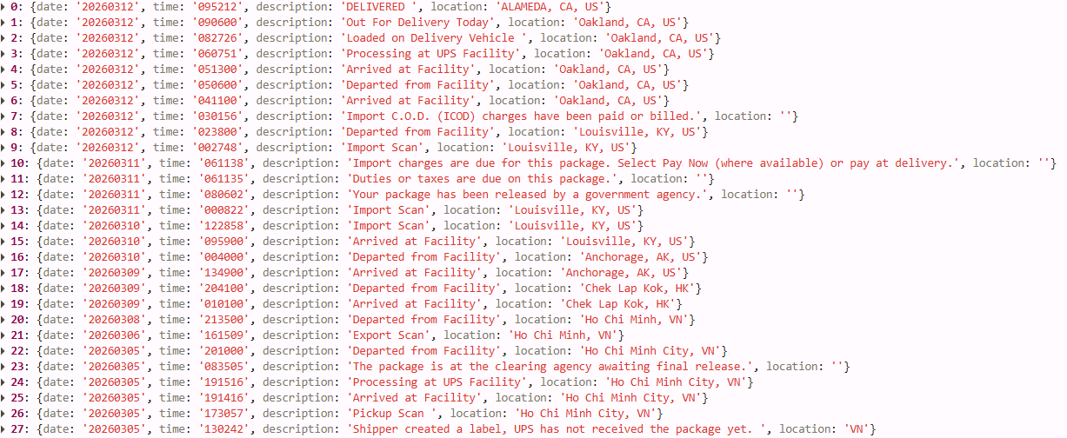
- In Figure 17. The reroute bypasses the Persian Gulf entirely by diverting southward through Sri Lanka and the East African corridor before continuing through the Suez Canal and onward to the United States via the Atlantic
Figure 16: Tracking API of 1ZB8678F6735719517
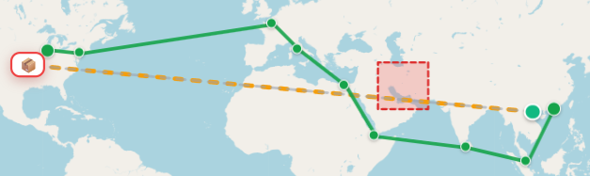
Figure 17: Scenario S1
The result of Figure 17 and scenarios gives a clear view of how LogiShop contributes to the cost impact of the shipment. The traditional method used by existing international delivery platforms provides strict rules and updates tracking data through their own APIs. LogiShop can implement a new way to interact with disruption cases that interfere with carriers’ choices—an algorithm to detect and compute in an instant for an optimal route to avoid critical zones.
The most significant financial exposure of SMEs is opportunity costs and contractual penalty fees. The outcome of these is when shipments fail to deliver on time. In international logistics management, delivery delays often cause penalties in trade contracts, which can lead to a higher charge fee on the invoice value for every day of late delivery. Beyond direct penalties, the opportunity cost of a delayed shipment can decrease sales, suspend workflow due to late delivery, incur higher costs, and cause distrust of customers.
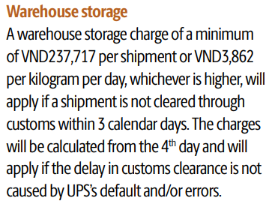
Results:

Figure 18: UPS Warehouse storage additional charge from 2025 to 2026
According to the 2026 UPS® Rate and Service Guide Vietnam, Effective December 21, 2025, Daily Rates. Each delay of the delivery date in the warehouse storage is USD 9.35 per day.
The formula for the total freight cost:
Cost total = Cost UPS base shipping + Cost storage + Cost business delay
Cost total = 294.81 + 28.05 + 26.53 = 349.39 USD
 | Route 1 - S0 Baseline | Route 2 - US–Iran Conflict
UPS base shipping | $ 294.81 | $ 294.81
Estimated Transit Time | 7 days | 10 – 12 days
Storage cost |  | $ 28.05
Business delay | - | Estimate 3 – 5 days  9% per shipment
Total | $ 294.81 | $ 349.39  Approximately 18.51% higher than Route 1 – S0 Baseline
Table 13: Test comparison price
Note: the difference in the route 2 result is due to the assumed risk coefficient for the critical zones. The operating system currently focuses on route optimization, so the number 18.51% serves as an empirical parameter to support decision-making. This will be replaced with an actual, realistic parameter for real-time data after integration with the corresponding courier.

4.3.5. Reliability and Security

4.3.5.1. Reliability
A fundamental and reliable aspect of LogiShop is the success rate of its geocoding function, which is critical to the platform's core operation.
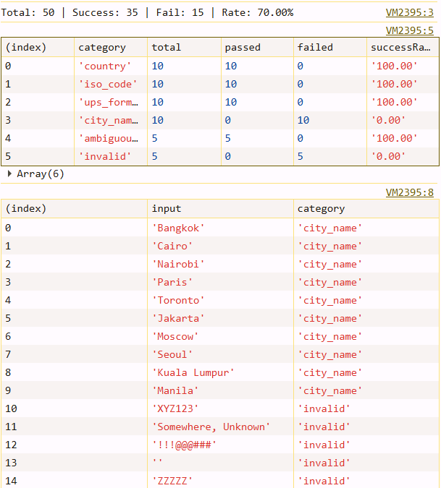
Figure 19: Geocoding Accuracy Test Results
To evaluate the geocoding accuracy of the system, a batch test of 50 location strings was conducted across 6 representative input categories using the GET API benchmark of the geocode endpoint. The result shown in Figure 19 demonstrates that the function achieve 100% success rate for country names, the same as ISO-2 country codes, UPS-formatted location strings. A bare city name only results in a failure to resolve, as the lookup is indexed by the country format of the UPS rather than city names alone. Junk strings completely return null due to an invalid format. The overall success rate across all 50 inputs was 70%, rising to 100% when restricted to realistic carrier-produced formats, which validates the geocoding pipeline for production use.

4.3.5.2. Security
Security is a fundamental requirement for any web application platform to manage sensitive data, confidential business information, especially in this LogiShop, which focuses on shipment records, customer details, order histories, and real-time tracking data. As Jaiswal et al. [9] note, security testing has become a critical activity in web applications because the increase in system complexity results in challenges for a system to secure the safety of sensitive data exposure and disrupt logistics operations.
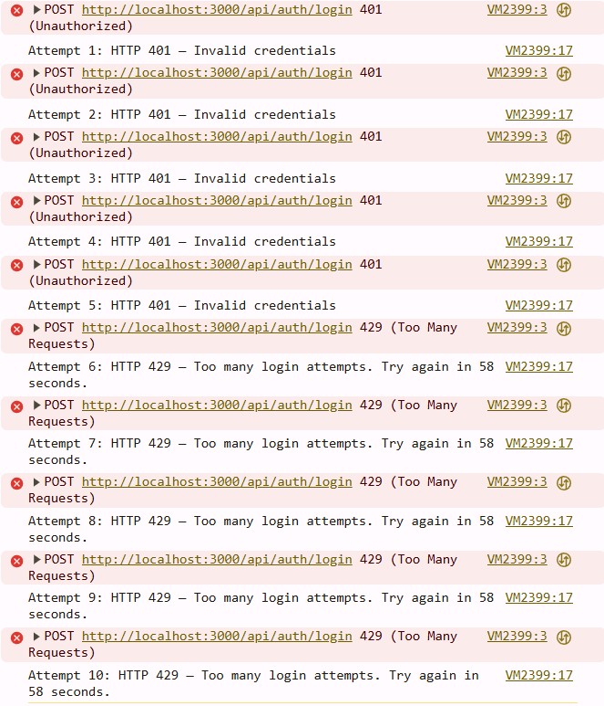
Figure 20: 10 requests in 60 seconds
 | Attempt | Status | Message
0 | 1 | 401 | 'Invalid credentials'
1 | 2 | 401 | 'Invalid credentials'
2 | 3 | 401 | 'Invalid credentials'
3 | 4 | 401 | 'Invalid credentials'
4 | 5 | 401 | 'Invalid credentials'
5 | 6 | 429 | 'Too many login attempts. Try again in 58 seconds.'
6 | 7 | 429 | 'Too many login attempts. Try again in 58 seconds.'
7 | 8 | 429 | 'Too many login attempts. Try again in 58 seconds.'
8 | 9 | 429 | 'Too many login attempts. Try again in 58 seconds.'
9 | 10 | 429 | 'Too many login attempts. Try again in 58 seconds.
Table 14: Rate Limit – DDoS

- Allowed: 5 attempts (401)
- Blocked: 5 attempts (429)
- Block rate: 50% over 10 attempts
- Rate-limit threshold: 5 attempts per 60 seconds per IP

A simulation of brute-force login attacks, a simulated penetration test was conducted, sending 10 failed login requests to POST /api/auth/login using incorrect credentials, as shown in Figure 20. The first 5 attempts were returning, indicating normal rejection of wrong passwords or usernames. From the sixth attempt, the server responded with HTTP 429 to confirm the threshold of 5 attempts within 6 seconds.

CHAPTER 5

DISCUSSION AND EVALUATION

Discussion
The development of LogiShop demonstrates that the main challenge in international shipping is not only about data collection, but also data coordination. In many realistic workflows, shipment information exists but happens to spread across tools, systems, and operators, and customers need to communicate to combine the complete records, updates, and textual route before making any more decisions. Through implementation and testing, the thesis found that such fragmented operations create unavoidable delay, inconsistent statistics of orders, and cause higher operation overhead. The purpose of LogiShop is to address the core problems and solve them by bringing them into one singular platform.
One of the important outcomes of the discussion is the immense importance of the visualization mapping system at the route level provided by the web application. Traditional tracking systems focus on logs, and update information is presented in text form without adequate geographic location information. LogiShop with map visualization enhances the readability of package tracking by highlighting the route and shipment density. Transition from text-based tracking to geospatial tracking for international delivery.
Another vital issue involves the optimization of the process via synchronization of updates tracking. The ability to update the information with just one click and to refresh the interface will simplify the procedure and help identify any inconsistencies in the information coming from the internal data and that of carriers. On the level of systems management, this will guarantee the presence of up-to-date data and minimal use of mental power on the part of users who will not need to worry about having their information updated on multiple interfaces. On the level of operations management, this will guarantee smooth communication in the provision of services.
The disruption handling route issue opens up an interesting topic for discussion. In most logistical applications, disruptions are treated as external factors that users and employees are aware of through manual actions. In this particular case, the disruption state is implemented in the actual flow and is calculable rather than estimated based on guessing and contacting various carriers. This is despite the fact that, at present, the algorithm provides for a simplified view of geographic risks.
On the other hand, the implementation process shows practical challenges and limitations. Route accuracy depends on the quality of input data, geocoding, and employee experience. Timing issues related to the synchronization of external carriers need to be dealt with by merge and fallback rules. The map generation process needs to take into account obstacles as the route size keeps increasing. These findings are not flaws; rather, they demonstrate the actual engineering process of constructing the system within a specified scope and timeline.
In summary, the analysis proves that LogiShop creates a breakthrough and value within the scope of the thesis topic. While this project will not replace any enterprise logistics system platform, it lays the foundation for an architecture and engineering process and tackles challenges in international shipping logistics.

Evaluation
In this section, the improvement of the applied system over the workflow pattern without integration can be seen from aspects such as functionality, update effectiveness, route understandability, and use in decision-making about shipment in international situations.

5.2.1 Baselines

The baseline describes a disjointed process where logistics information is managed by the operator through tools. In the baseline scenario, order information is sourced from one place, tracking information is also sourced from another place, while the route information can be managed by the carrier, does not exist, or is managed manually. There is a problem with communication between users/staff since there are disconnecting stages prior to checking the status of the package. This is a typical problem encountered in SME operations systems.
LogiShop differs from the baseline in that it allows order sourcing, information tracking, and routing in one system. The baseline acts as a practical benchmark for the workflow.

5.2.2. Experimental Protocol

The testing protocol employs functional scenarios rather than artificial benchmarks. It is appropriate for the current scope of the project since the primary concern is the usability of the process, not just of the algorithm.
The testing protocol includes a repeated performance of functional scenarios like logging into the user interface, searching through orders, performing track-refresh, displaying a route, activating disruptions, and observing the effect of a rerouting calculation on the displayed route. Each scenario is analyzed for conformance with expected behaviors. They involve checking if the track refresh shows up on the detail panel, if the highlighted route matches the tracked order, and if disruptions cause a rerouting process to begin.
Observational metrics such as the number of actions needed for retrieving an update, interpretability of the route, and consistency of information between the backend and frontend interfaces are additional criteria.
The assessment comprised both functional verification and quantitative assessment of the system's performance. The system performance was assessed through the use of performance.now() and console.time() to measure the performance of front-end operations, while load testing was done using specialized applications (k6) to test the performance of APIs. The time taken to execute an algorithm was directly assessed in the disruption-router.ts module. Map performance was assessed using Performance Chrome Developer Tools. The efficiency of workflow processes was measured both on conventional fragmentary approaches and LogiShop.

5.2.3. Threats to Validity

First, an external API dependency can affect evaluation outcomes. Tracking synchronization relies on the carrier. Temporary API latency or availability issues may affect refresh behavior independently of local system logic.
Second, data quality can directly affect the system performance. Route, locations, and ports with inconsistent naming may corrupt the geocoding accuracy, downgrade the visual route output, in both quality and quantity.
Third, the evaluation environment is primarily development-oriented. Performance and stability characteristics in production may differ due to network topology and deployment environment.
Despite these threats, the evaluation remains valid for its intended goal: to support the implemented architecture and function comprehensively and improve practical applications.

5.2.4. Quantitative Results and Analysis
The quantitative evaluation demonstrates that LogiShop not only meets functional requirements but also delivers strong performance characteristics suitable for small and medium logistics operations. The average end-to-end tracking cycle of 5.7 seconds, combined with a low update lag, provides near-real-time visibility. The Dijkstra rerouting algorithm maintains sub-50ms execution time even with complex scenarios, enabling practical disruption handling.
Map rendering remains smooth for low operational volumes (< 1,000 routes), while operational efficiency improved dramatically with an 85.4% reduction in manual effort. These results validate the system’s practical value and support the thesis objective of creating an economically beneficial logistics platform.

Limitations and Challenges

However, although LogiShop achieved its main objectives, several limitations remain.
A key limitation is integration. The current system is focused on a dedicated carrier synchronization path, so multiple carriers are not yet fully achieved.
Another limitation lies in the precision of the disruption-handling model. The model should be trained with AI to achieve more robust, advanced geospatial representations.
Performance constraints also affect implementation decisions. Route visualization at high volume requires client-side capping and optimization across all interfaces. While large-scale deployments require server-side rendering to render effectively
Finally, evaluation depth is limited by the thesis timeframe and environmental constraints. Longevity production data and a huge amount of user studies were beyond the scope, so the conclusion should be interpreted as strong implementation evidence rather than final institutional validation.
These limitations do not reduce the value of the project; instead, they define a clear roadmap for future work and confirm that the current implementation is a credible foundation for continued development.

CHAPTER 6

CONCLUSION AND FUTURE WORK

Conclusion
This thesis aimed to present the design and focus point of LogiShop, a web-based platform for international shipping and delivery management. The project was motivated by a practical industry problem: the amount of demand and shipment data of users keeps getting higher, with only a fragmented system, which may cause disconnected systems, resulting in delayed updates and inconsistent decision-making. To address this problem, Logishop was developed as an integrated platform that combines order management, a tracking system, and route visualization in one operation.
From a technical perspective, the implemented system demonstrates that a modular architecture can help a practical logistic workflow without requiring enterprise-scale at the beginning stage. With API route handlers, structural data layer, and external carriers synchronization, these are key to the thesis because they reduce the need for manual workflow.
Among the functional aspects that contribute to the value of the system is the transportation map module. This module adds more interpretability to the process of shipment analysis compared to traditional log-based approaches. Users can analyze the shipments' locations as well as their status in the corridors, thanks to this module. Furthermore, the functionality of the one-click refresh contributes significantly to the efficiency of data analysis, since it combines order and shipment data in one operation.
Another significant innovation in this work involves the development of a disruption-aware routing framework. Though currently only available in prototype form, this framework adds a novel element to the platform in that it provides intelligent decision-making based on disruption awareness by identifying potential disruptions in a route and recommending new routes to be followed.
The thesis concludes that LogiShop fulfills its primary objectives efficiently. This solution ensures comprehensive shipment monitoring capabilities, boosts workflow productivity, and builds a platform for developing further logistics intelligence solutions. Furthermore, this solution can be viewed as an example of a software artifact and engineering case study.

Future work

Although LogiShop achieved its thesis goals, several extensions can significantly improve both research depth and production completion.
Firstly, multi-carrier integrations must be achieved in the near future. Currently, there exists integration with a main carrier workflow; however, in practical application of logistics systems, multiple carriers are often used as an alternative for different scenarios – FedEx and DHL can be good examples.
Secondly, a real-time event-based system must be achieved in the future. Currently, all data updates can only be done through refreshing; these can include certain refresh cycles or using a manual tracking button for a specific shipment. Webhooks, channels… must be used in order to decrease response time in receiving updated information on shipments.
Thirdly, further development must be made towards a more complex model when it comes to logistics decision-making. Current logistics decision-making algorithms work fine as a simple demonstration of how the model works; future iterations should involve more parameters, including fuel price, highway congestion, and price from a certain brand of carriers.
Fourthly, there is a need for better detection capabilities. The current detection zones are modeled using a realistic geometry zone. However, future designs can use geospatial data and risk feeds together with dynamic update disruptions from reliable sources to enhance route impact realism and the reroute handling process in a more effective manner.
Fifthly, there is a need to conduct scalability and deployment evaluations. It is imperative that the production level study examines the performance of the system under large volumes of routes and users, together with geographical spread.
The sixth priority is user and operational evaluation. Future research can include structured logistics operators, trials in operational settings, and analysis against tools. Such an evaluation provides stronger empirical evidence of cost savings, response time improvement, and service quality.
In summary, future work should evolve LogiShop from a strong implementation prototype into a broader logistics intelligence platform with multi-carrier support, real-time responsiveness, richer economic optimization, and production-scale validation. These directions naturally extend the current thesis and provide a clear path toward practical deployment and continued academic contribution.

REFERENCES

[1] World Bank, Connecting to compete 2023: Trade logistics in an uncertain global economy – The Logistics Performance Index and its indicators. 2023. [Online]. Available: https://lpi.worldbank.org/sites/default/files/2023-04/LPI_2023_report.pdf
[2] D. Bartulović, B. Abramović, N. Brnjac, and S. Steiner, “Role of air freight transport in intermodal supply chains,” Transportation Research Procedia, vol. 64, pp. 119–127, 2022, doi: 10.1016/j.trpro.2022.09.015.
[3] Y. D. Rosita, E. E. Rosyida, and M. A. Rudiyanto, “Implementation of Dijkstra algorithm and multi-criteria decision-making for optimal route distribution,” Procedia Computer Science, vol. 161, pp. 378–385, 2019, doi: 10.1016/j.procs.2019.11.136.
[4] Ship24, “Global tracking API.” [Online]. Available: https://www.ship24.com/tracking-api
[5] TrackingMore, “API quick start.” [Online]. Available: https://www.trackingmore.com/docs/trackingmore
[6] World Economic Forum, “4 ways geopolitical tensions are increasing carbon emissions,” 2024. [Online]. Available: https://www.weforum.org/stories/2024/03/geopolitics-carbon-emissions-ukraine-red-sea/
[7] Logistics.gov.vn, “Logistics service businesses in Vietnam transform digitally to reduce costs,” 2024. [Online]. Available: https://logistics.gov.vn/logistics-service-businesses-in-vietnam-transform-digitally-to-reduce-costs
[8] R. Sahoo, B. Bhowmick, and M. K. Tiwari, “Developing a model to optimize the cost of consolidated air freight considering the varying scenarios,” International Journal of Logistics Research and Applications, vol. 26, no. 8, pp. 1035–1059, 2023, doi: 10.1080/13675567.2021.2010682.
[9] A. Jaiswal, G. Raj, and D. Singh, “Security testing of web applications: Issues and challenges,” International Journal of Computer Applications, vol. 88, no. 3, pp. 26–32, 2014, doi: 10.5120/15334-3667.

